# Table Builder and Tree Builder Implementation

## Information to Implement Table Builder:

### Creating a new Builder class:

A table builder class corresponds to a table configuration. All the table-level as well as column-level properties should be configured in the builder class. When creating a new builder class, you should typically extend one of the abstract base classes provided by the MVC infrastructure:

* **AbstractConfigurableTableBuilder:** Use this base class if you are implementing a tree or table that supports configurable table views. This base class is located in the CoreHtmlComp module due to its dependency on the configurable table infrastructure.

**Note:** Configurable Table View means the user can customize how the table looks and behaves in the UI. Specifically, the user can control things like: Show/hide columns, Reorder columns, Sort data, Filter/Search and Save Views.

* **AbstractComponentBuilder:** Use this base class for tables and trees that do not support configurable tables.
* **AbstractComponentConfigBuilder:** Use this base class for info pages. You can also use this if you wish to separate your table or tree config builder from its data builder (not a typical use case).
* **AbstractComponentDataBuilder:** Use this base class for table and tree implementations where you have chosen to separate the config and data builder implementations (not a typical use case).

**Example:**

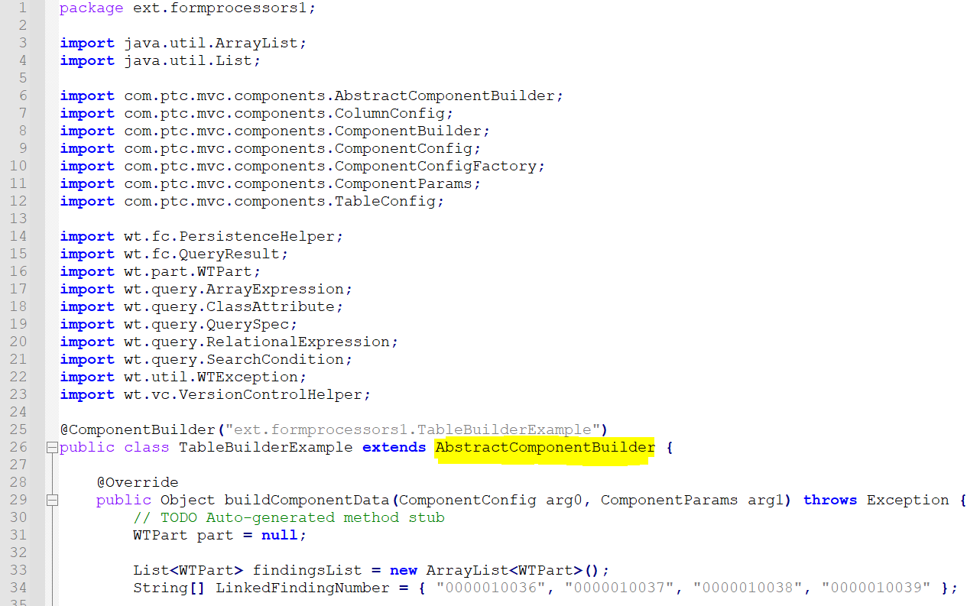

### Implementing the ComponentConfigBuilder API:

The table and column level configuration options can be specified by implementing ComponentConfigBuilder. ComponentConfigBuilder currently defines one method:

ComponentConfig buildComponentConfig(ComponentParams params);

The responsibility of this method roughly corresponds to what the describeTable tag does in 9.x versions.

**Example:**

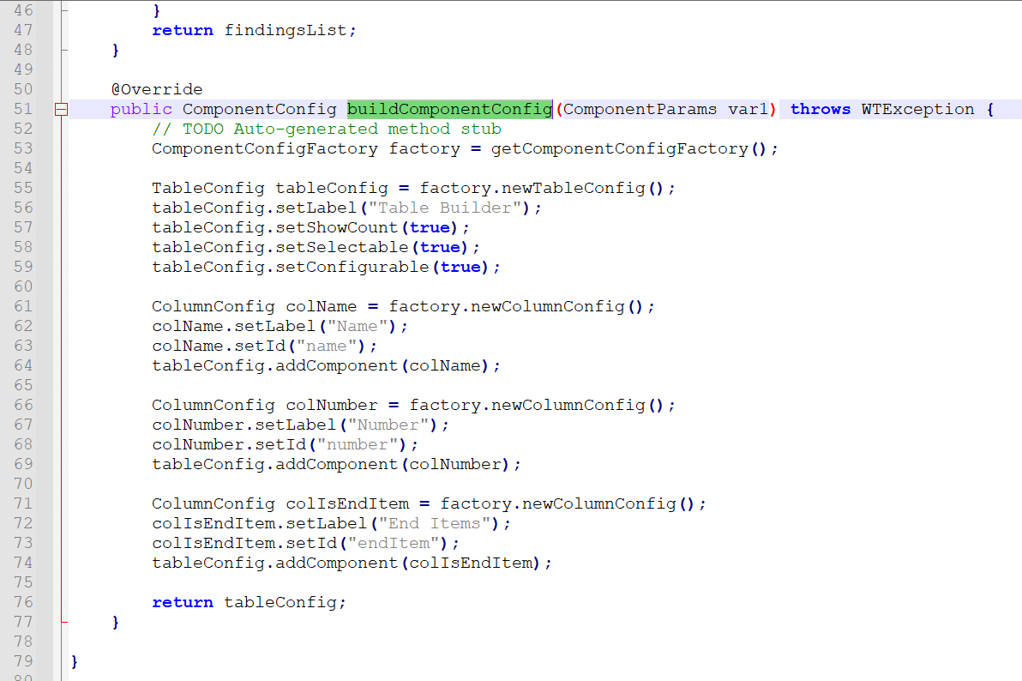

### Using ComponentConfigFactory to get Table/column ComponentConfig objects:

It is not necessary to create a ComponentConfig directly, instead use a ComponentConfigFactory. When extending the abstract base builder classes, the factory is available by calling getComponentConfigFactory().

When directly implementing ComponentConfigBuilder, also implement ComponentConfigFactoryAware. This will get you a reference to the factory when the builder is initialized.

Instance of TableConfig and ColumnConfig need to be used to specify table level and columns level customizations respectively. An example to get the TableConfig/ColumnConfig instance look like this:

ComponentConfigFactory factory = getComponentConfigFactory();  
 TableConfig table = factory.newTableConfig();  
 …  
 ColumnConfig col1 = factory.newColumnConfig(“column1Id”, false);  
 …   
 table.addComponent(col1);

Since column component is a nested component of table component, ColumnConfig can be added to the TableConfig using the addComponent() API as shown in above code snippet.

**Example:**

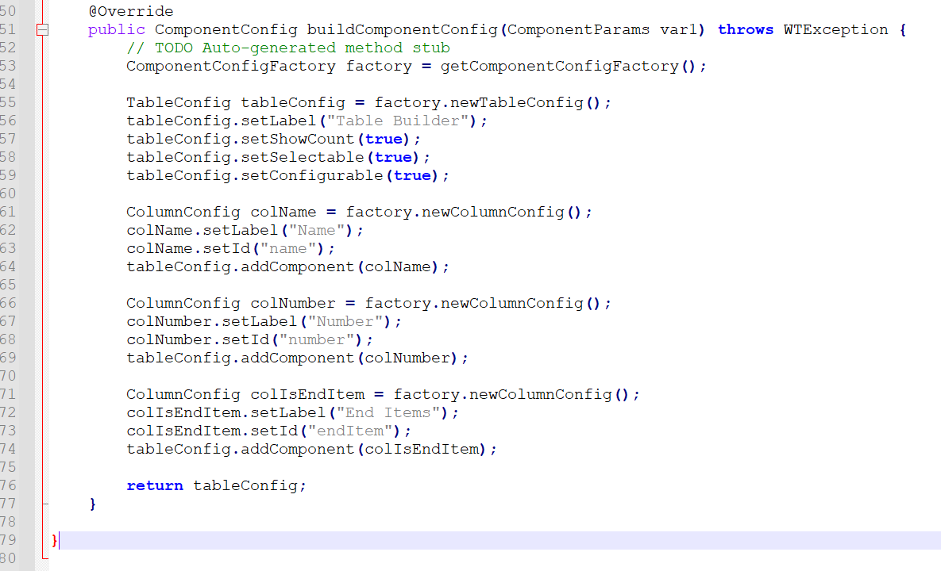

### Implementing the ComponentDataBuilder API

The data acquisition mechanism for table can be configured using ComponentDataBuilder interface. The data builder class needs to implement ComponentDataBuilder interface. ComponentDataBuilder currently defines one method:

Object buildComponentData(ComponentConfig config, ComponentParams params)

The responsibility of this method roughly corresponds to what the getModel/getIeModel tag do in JCA in the 9.x release stream.

**Example:**

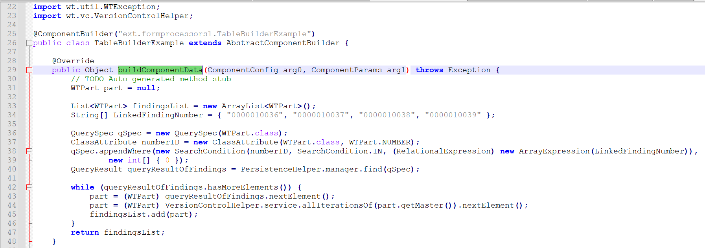

### Implementing your ConfigurableTable

You may choose to implement your ConfigurableTable as a static inner class of your builder, or to put it in a separate file. If you only intend to use it from within the builder implementation, then we recommend defining it as a private static inner class. An example:

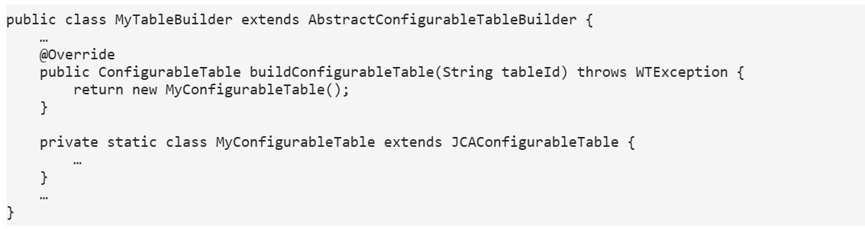

### Configuring separate config and data builders

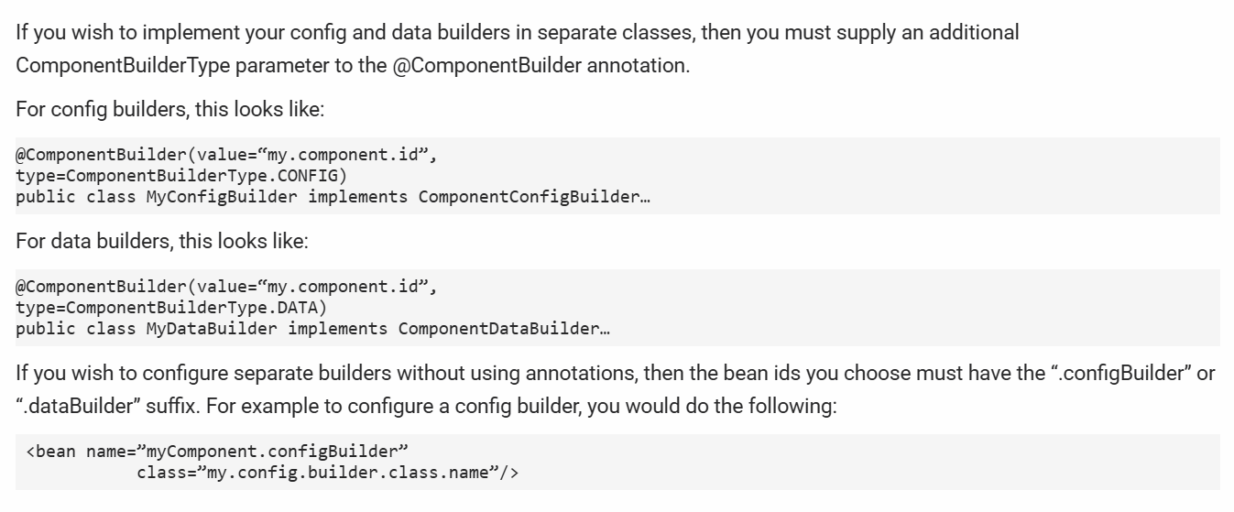

### Registering MVC builders

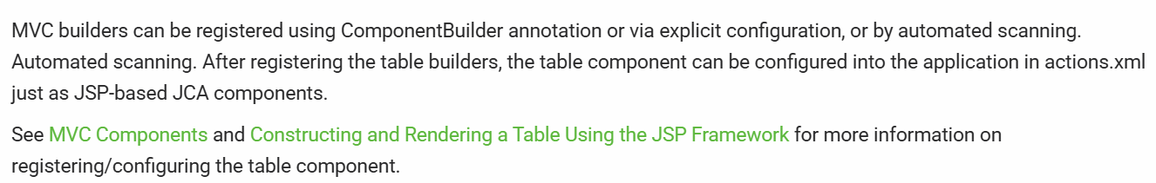

### Configuring a custom view jsp for table component

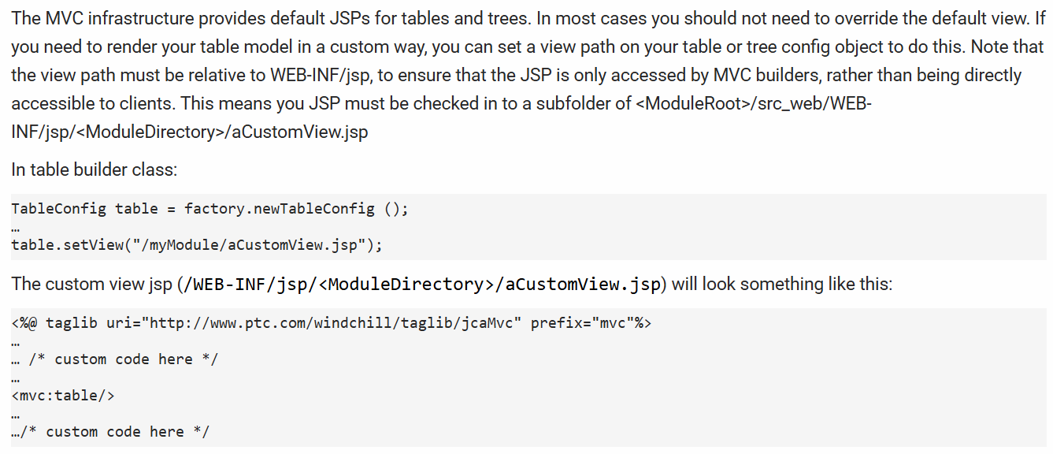

### Reuse of a Table Builder Class

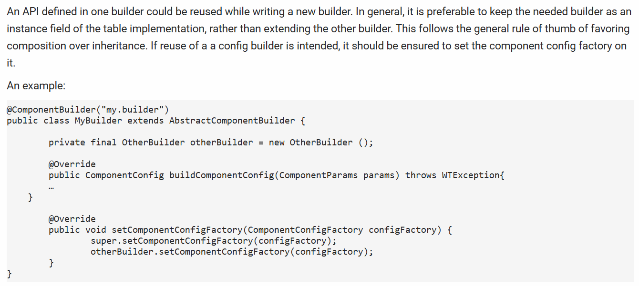

### Setting Sortable Columns

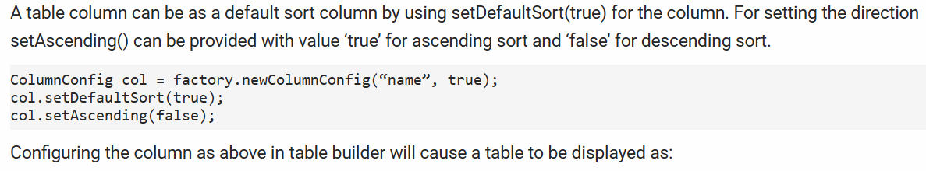

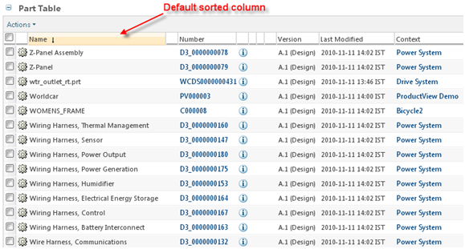

### Configuring Strikethrough Feature

JCA Table component has ability to "redline" individual rows.

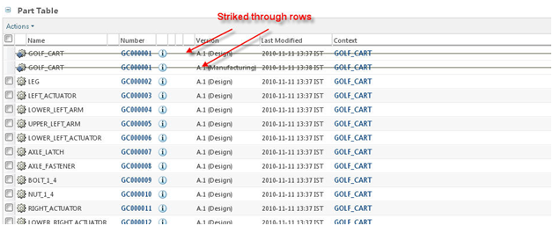

The following configuration points are available for specifying which row(s) will be strikethrough.

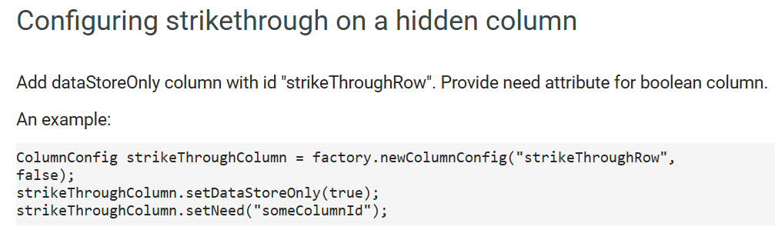

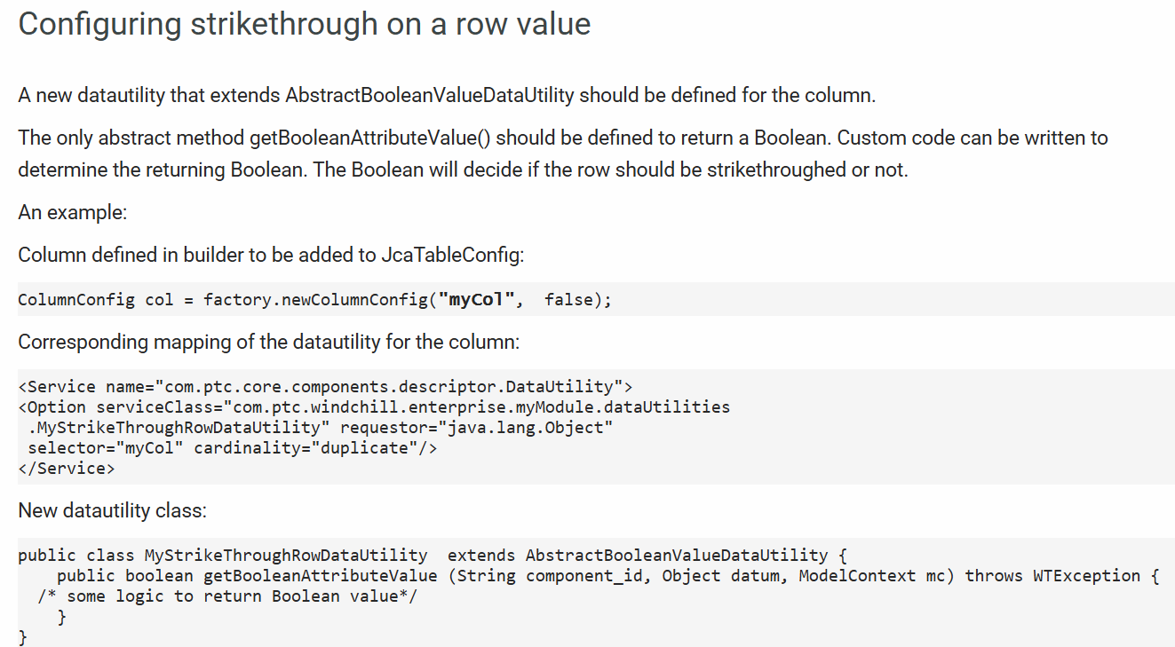

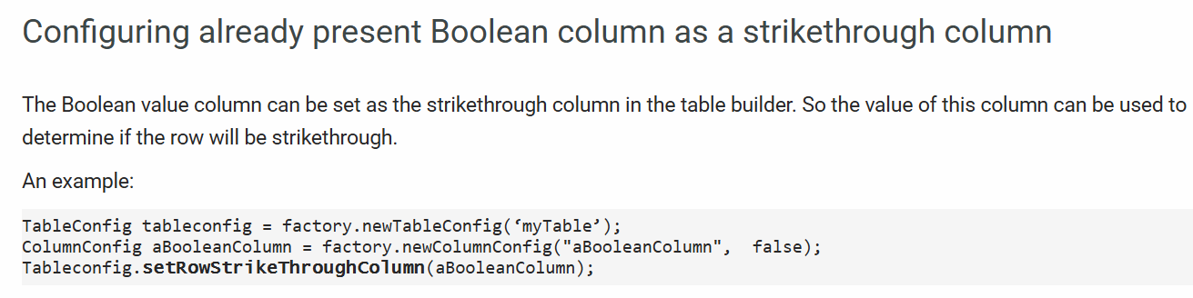

### Configuring Search in List

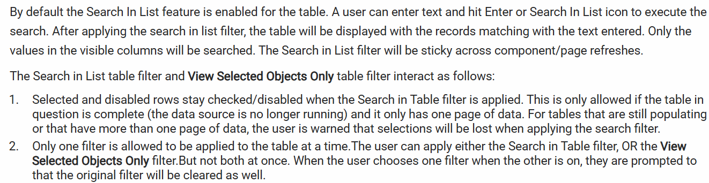



#### Disabling Search In List feature

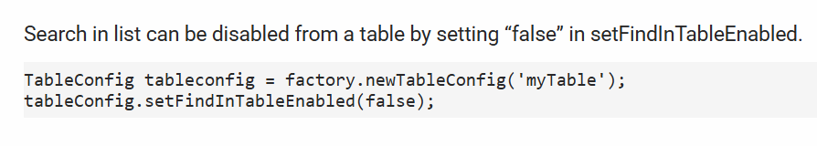

#### Search In List modes

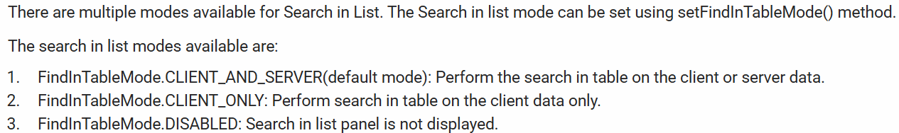

#### Non selectable row based on an existing visible column

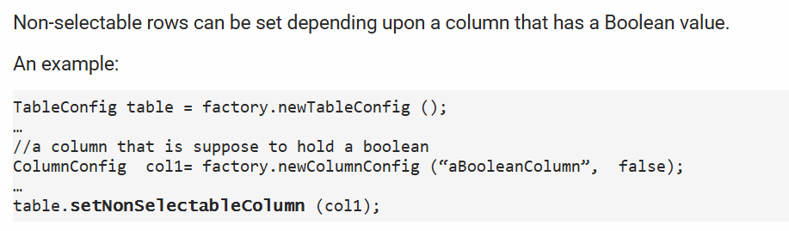

#### Configuring Non selectable rows based on a boolean attribute value available in the backing object

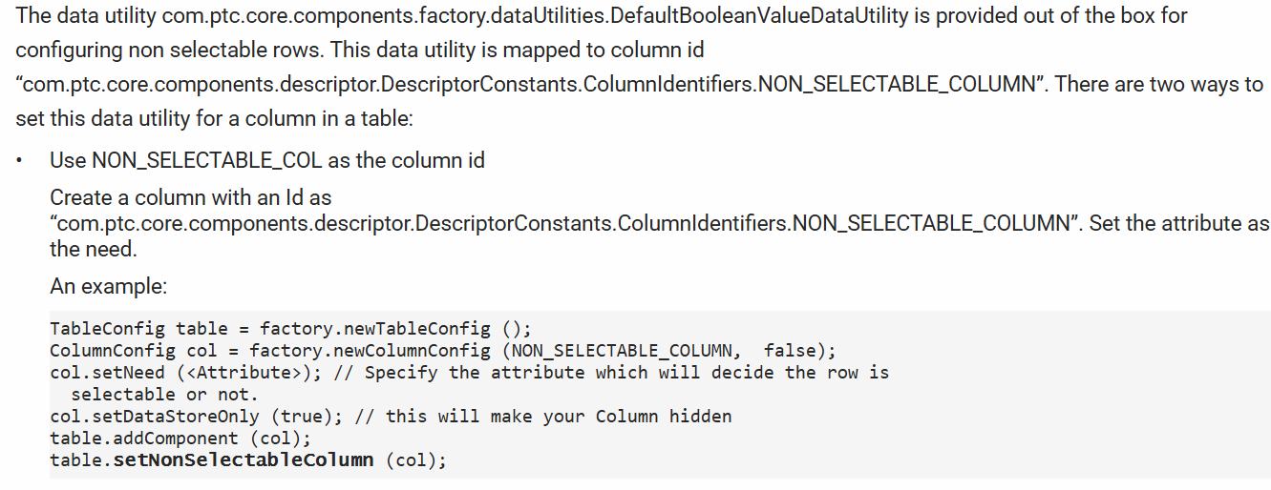

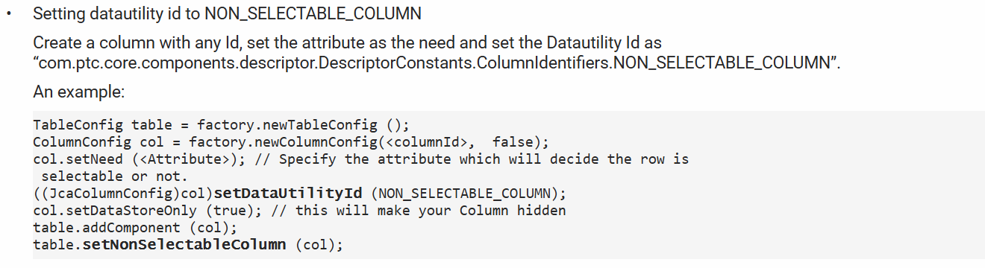

#### Non selectable row based on a custom data utility

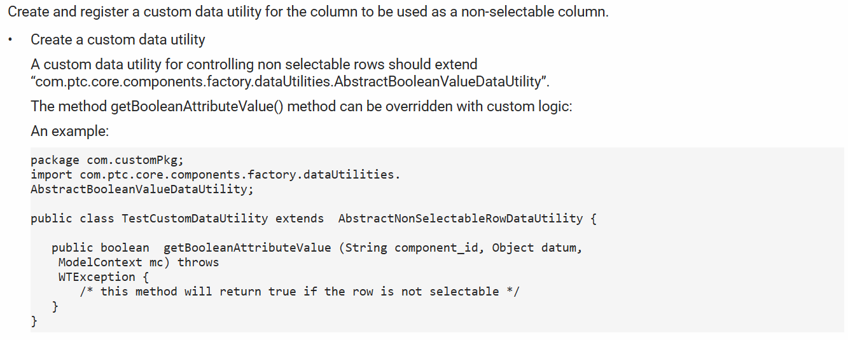

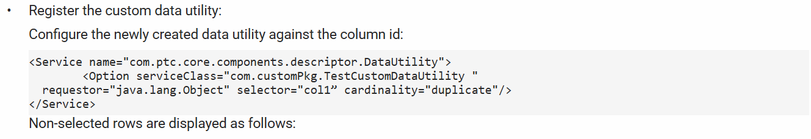

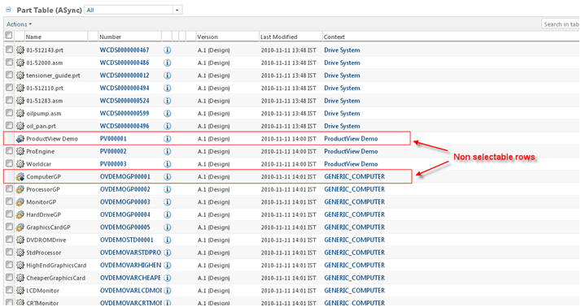

#### Configuring Data Store Only Column

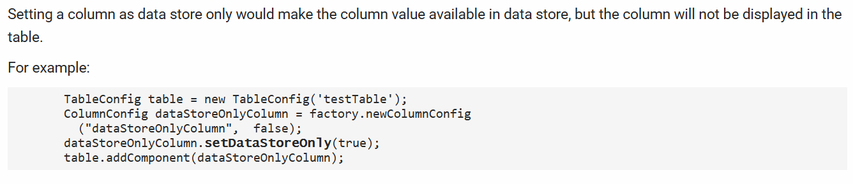

#### Configuring Column as a Hidden Column

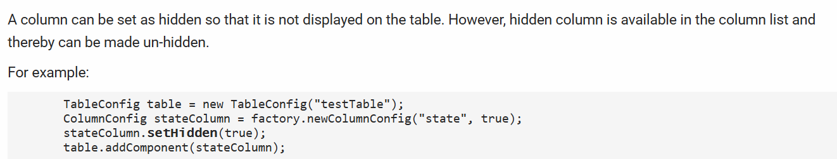

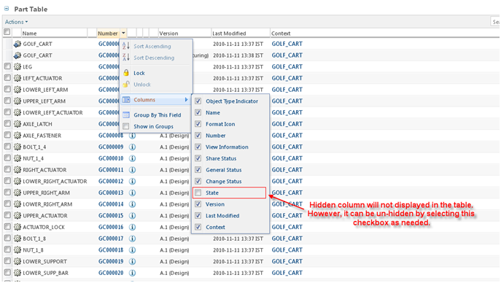

#### Adding a Toolbar

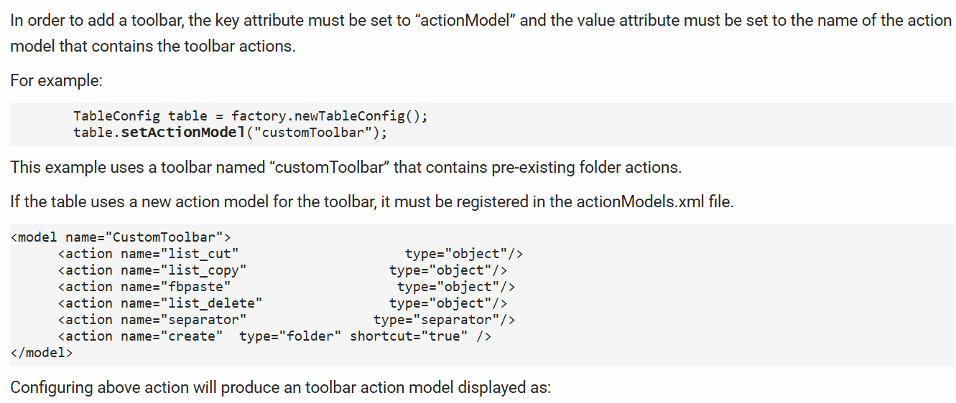

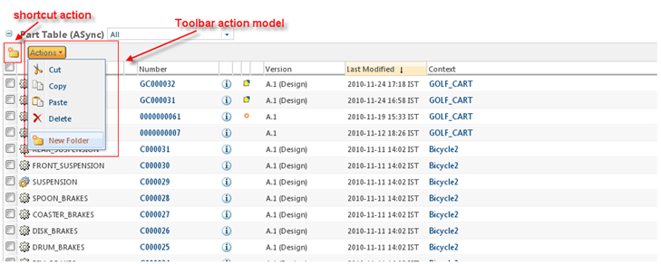

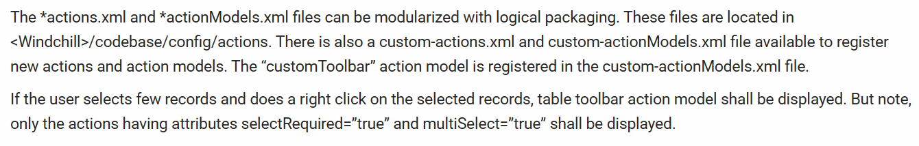

#### Configuring the Menubar

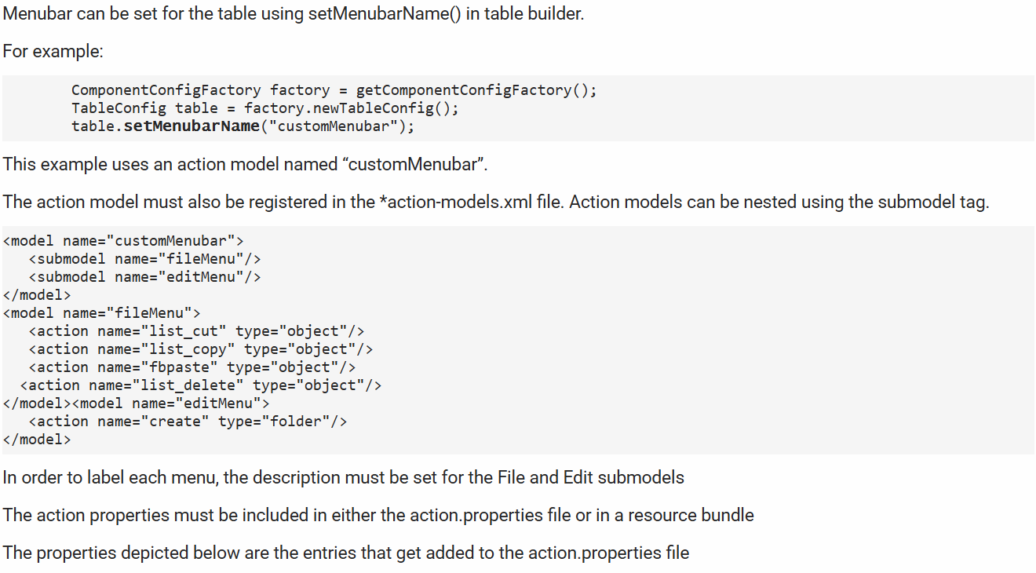

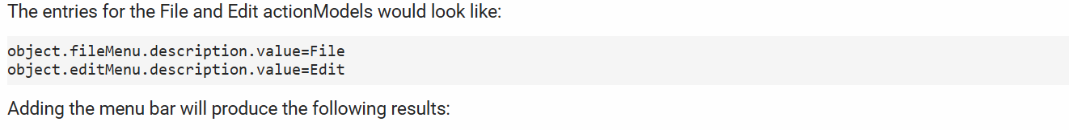

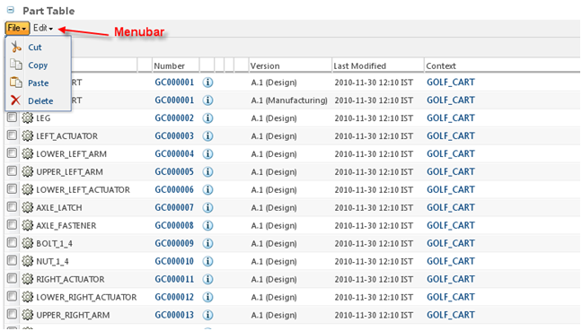

#### Enabling a Row Selection

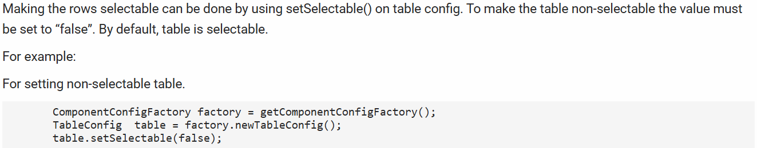

#### Single Select Table

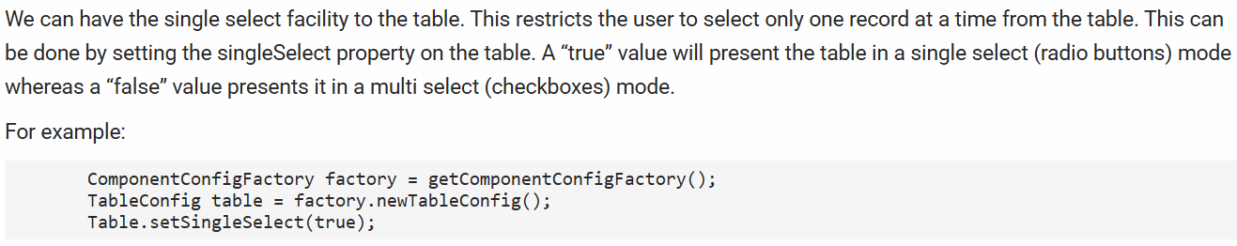

#### Pre-Selection row depends on an existing visible column

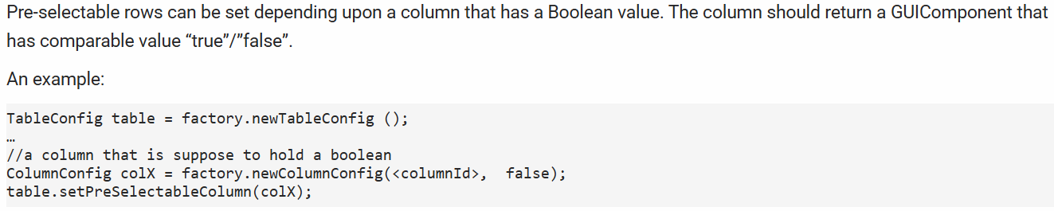

#### Configuring Pre selectable rows based on a boolean attribute value available in the backing object

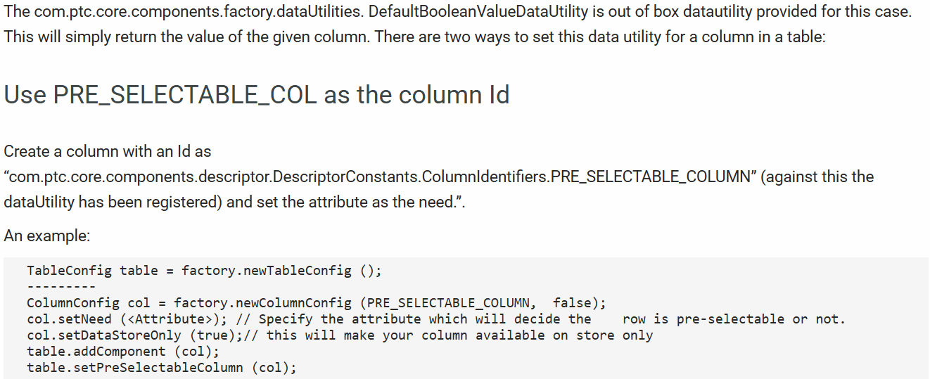

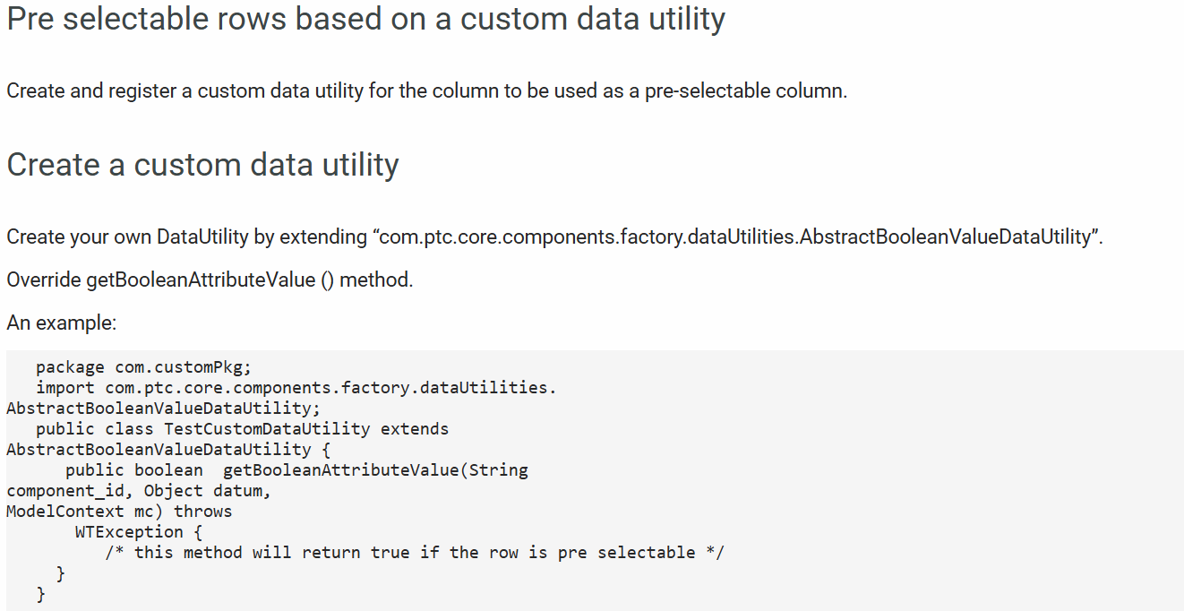

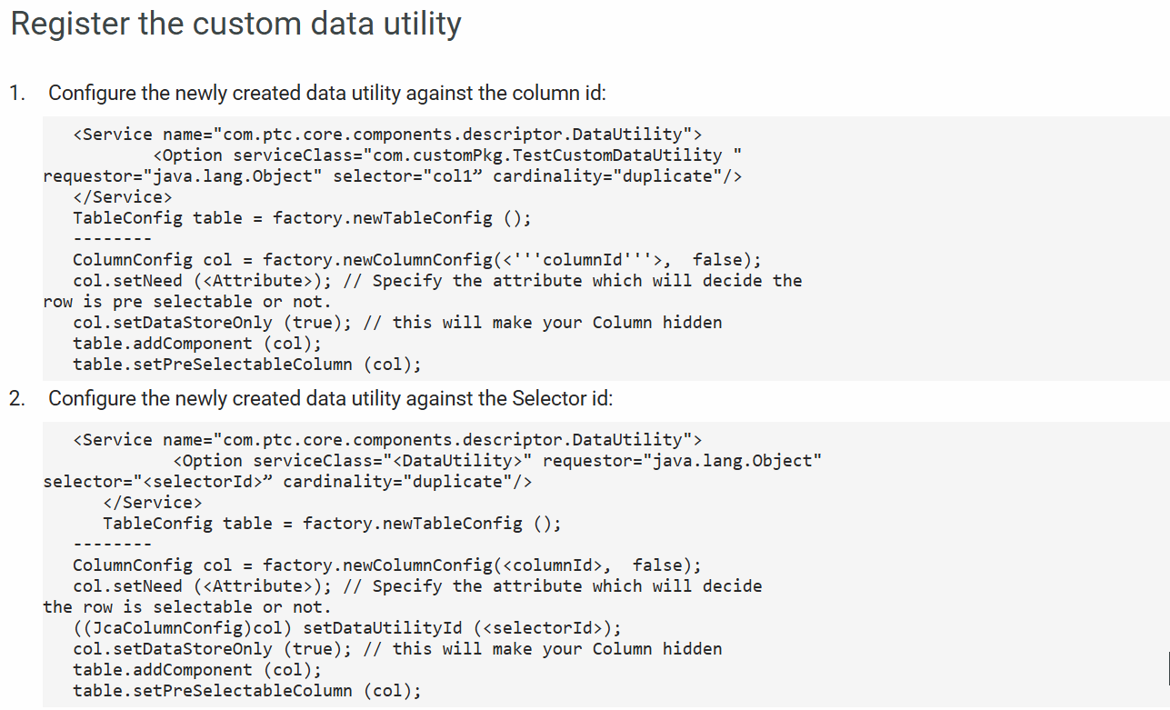

#### Configuring Column Wrap

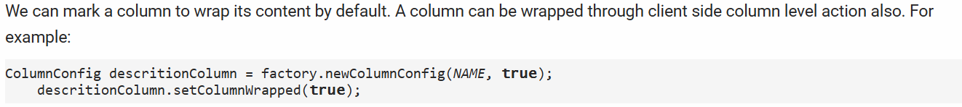

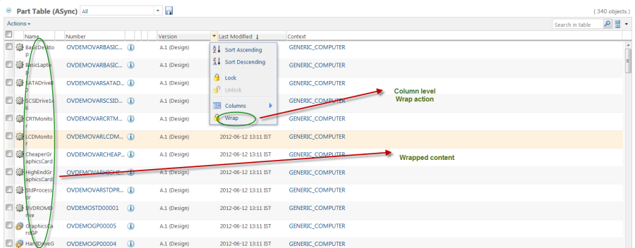



#### Adding a Help Icon

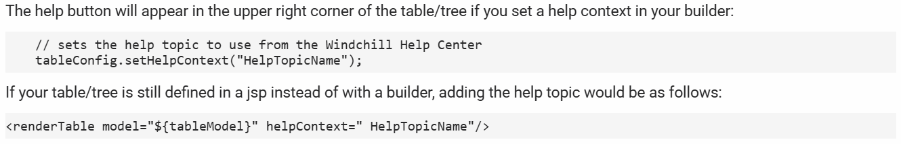

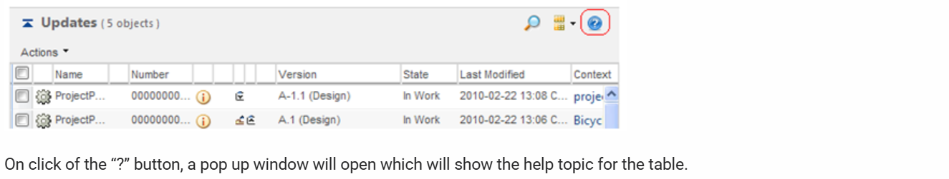

#### Specifying Datautility for Columns

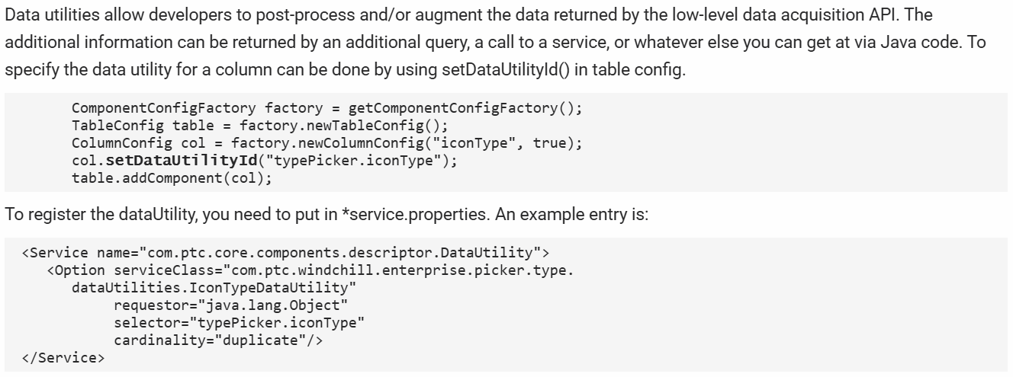

#### Configuring Table Columns as Hyperlinks

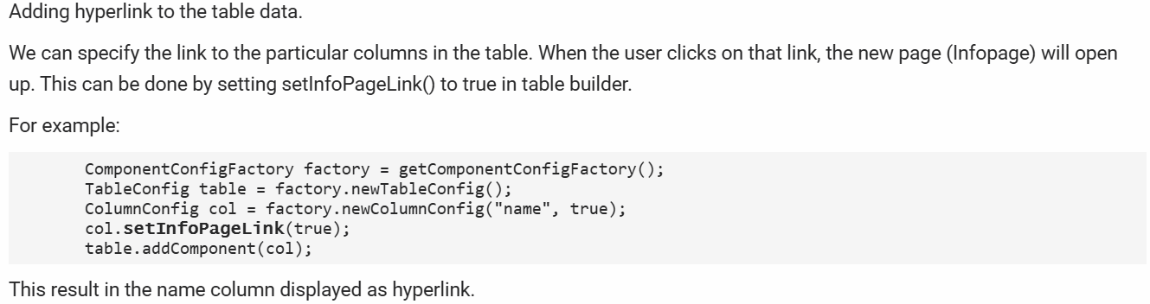

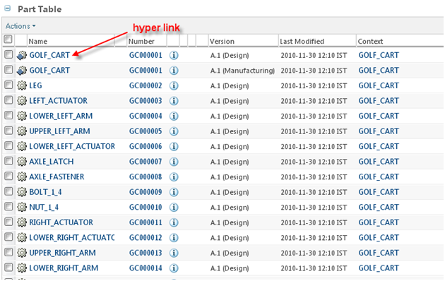

#### Creating a Customized View

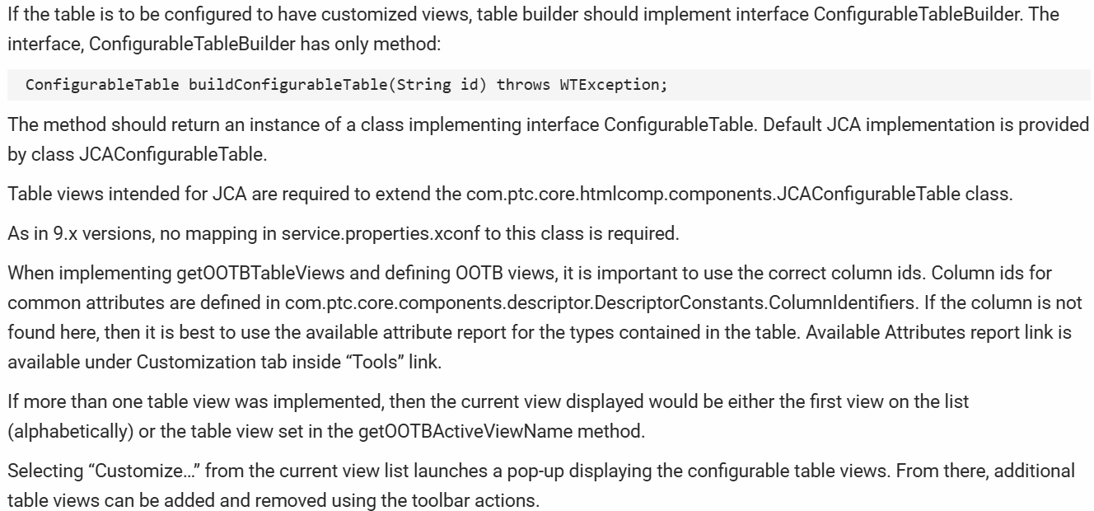

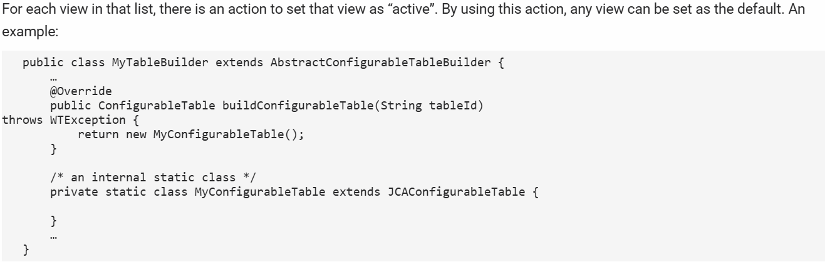

#### Setting Table Size Limits

The maximum number of rows that can be fetched in a table on a client can be set using the table size limit preference.

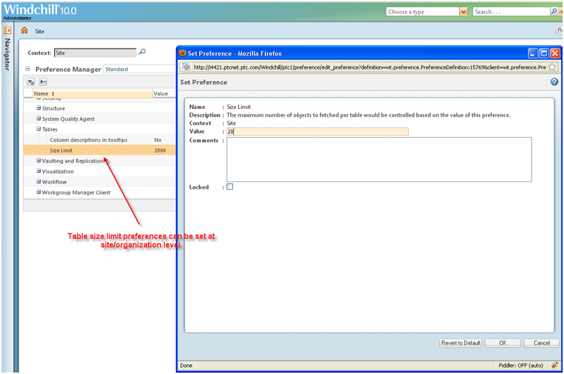

If the table has more data than the table size set in the preference, next/ previous links are displayed at the footer to navigate through the data:

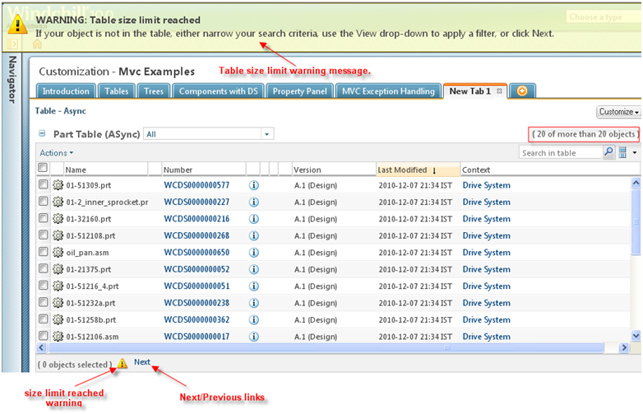

#### Using Tables in Wizards

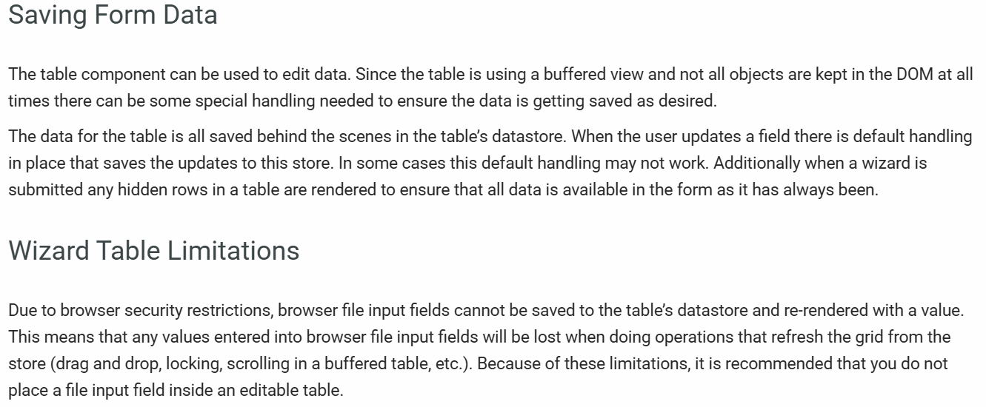

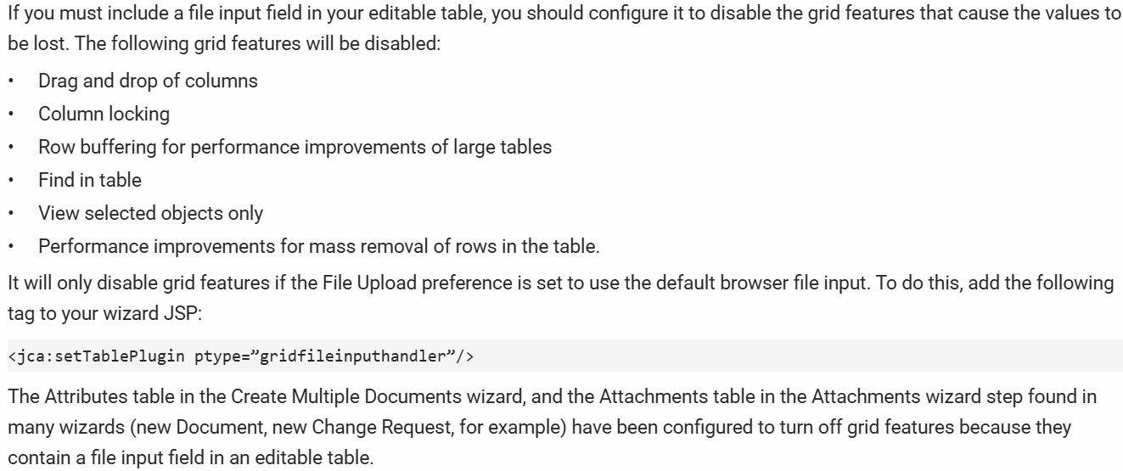

## Overview:

1. As a part of this implementation, we are going to create an action on WTPart as shown below.

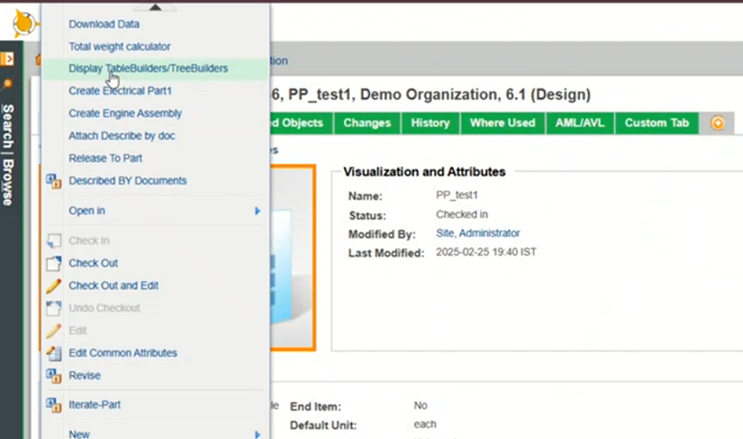

1. Upon clicking on that action, it will result the below window.

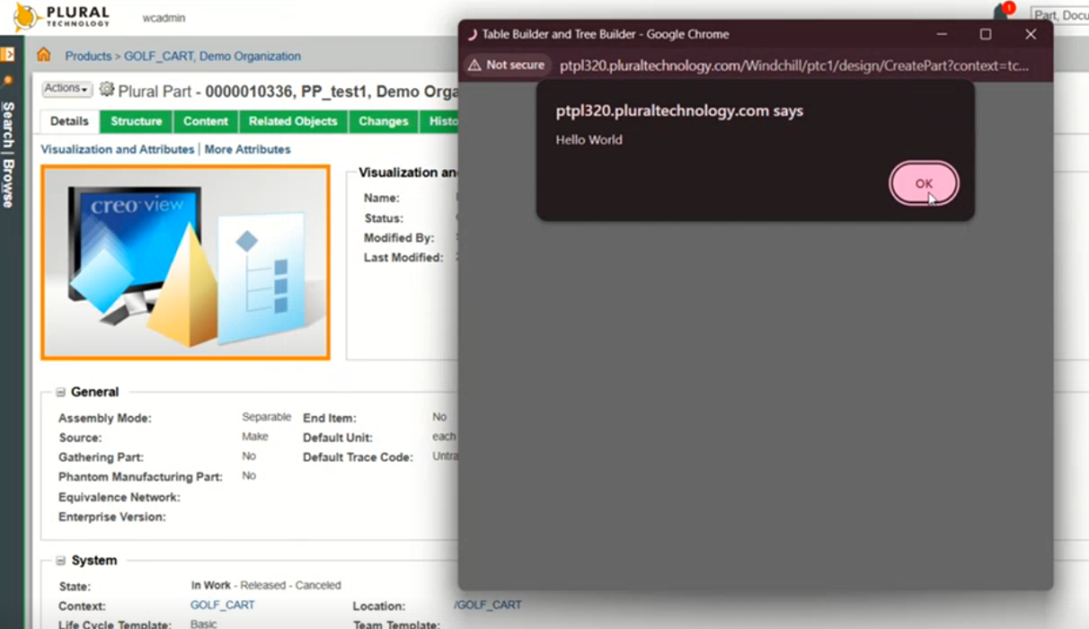

1. After clicking on Ok, it will launch the below page.

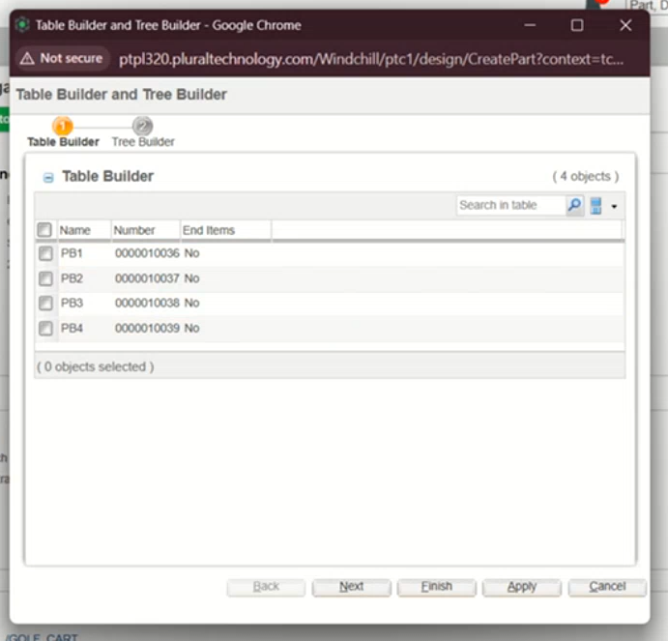

1. The values in **Table Builder** section are hardcoded as per the implementation in the below screenshot.



1. If we click on **Tree Builder** section, it will display the information as shown below as per the implementation.

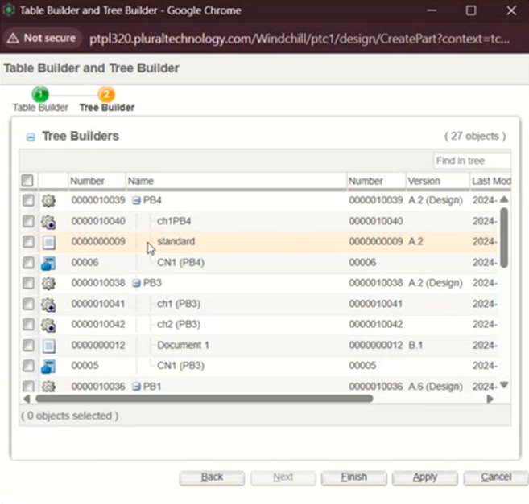

1. We can expand and collapse the tree structure in **Tree Builder** tab as shown below.

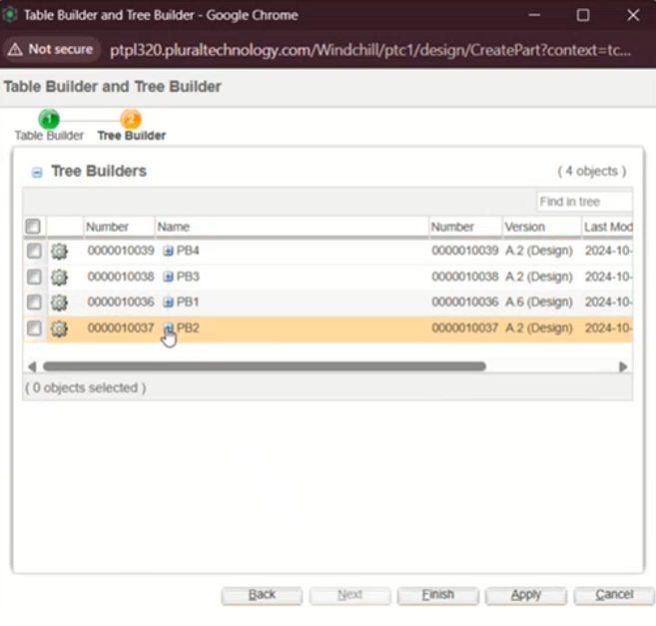

## Implementation Example from Gayatri:

### Table Builder:

1. Create a Table builder class as shown below.

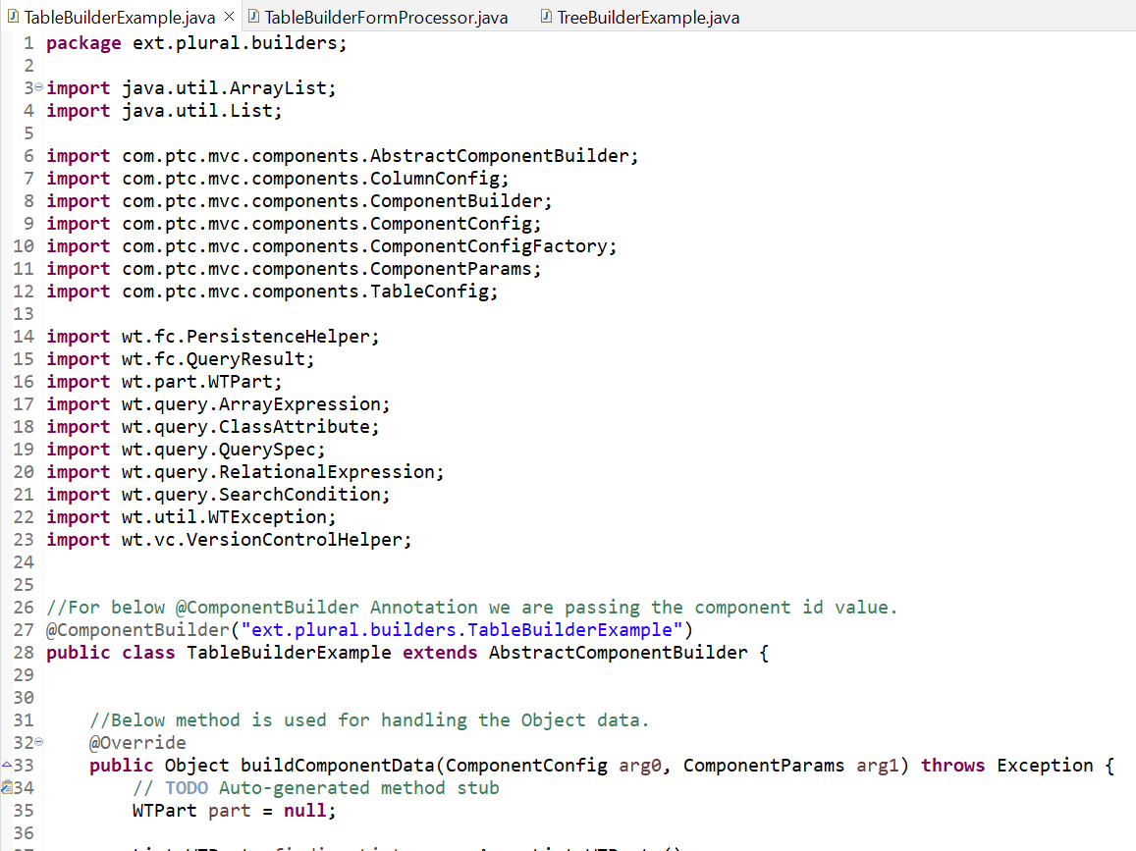

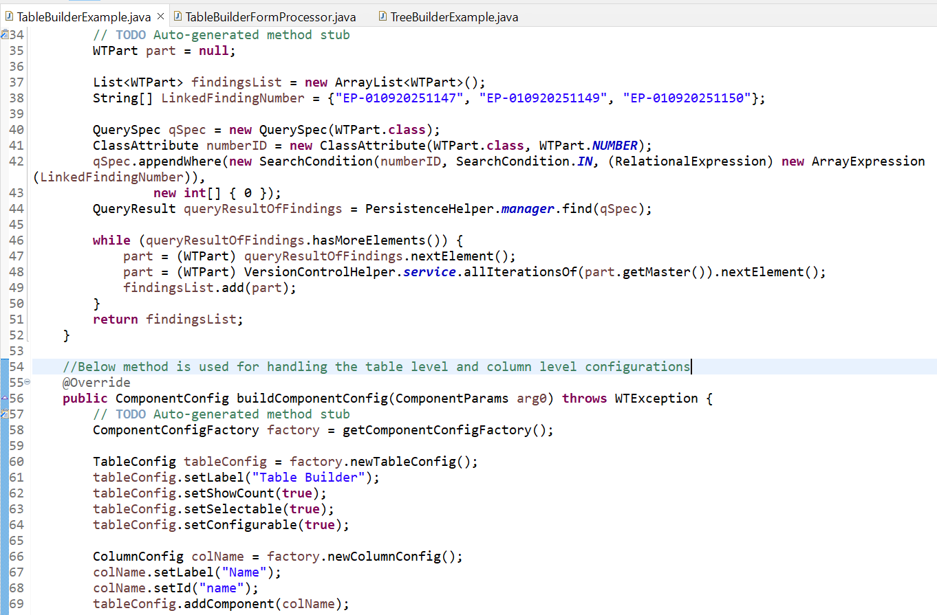

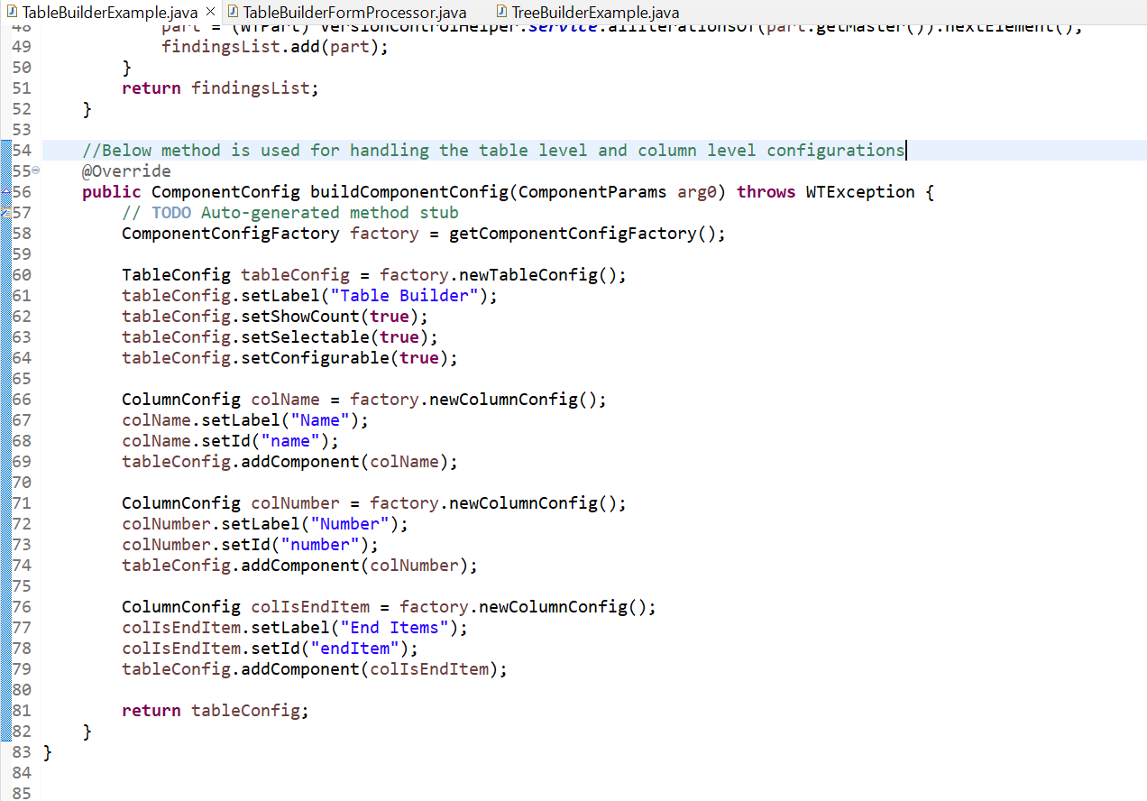

1. Register the table builder in **codebase/config/mvc/custom.xml** as shown below.

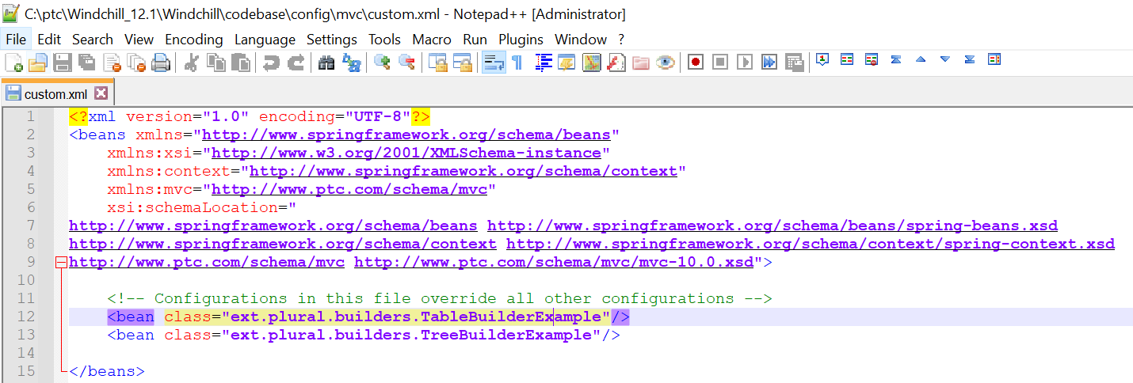

1. Create the JSP page as shown below.

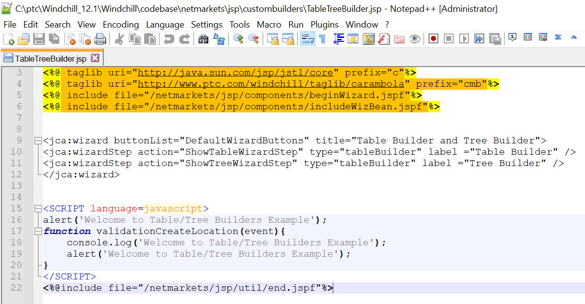

1. Create a Form Processor class as shown below to link it to the action.

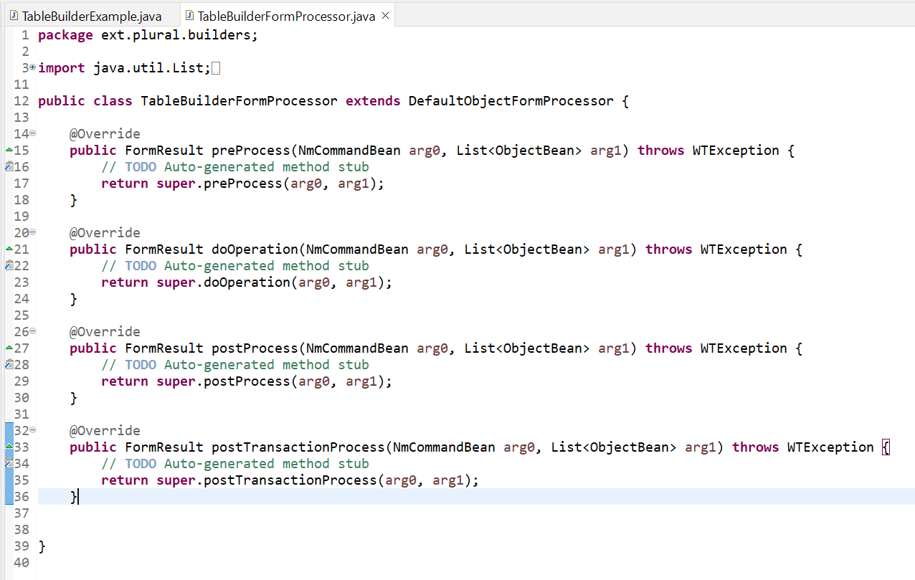

1. Add the below entries as shown below.

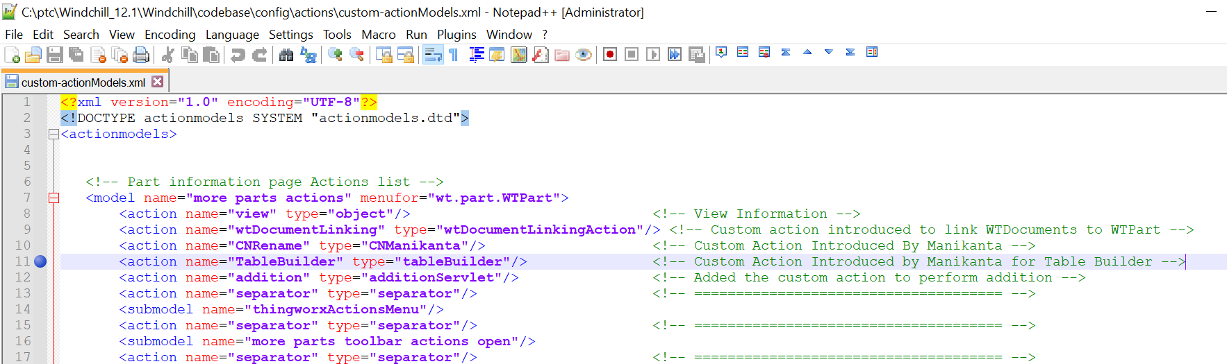

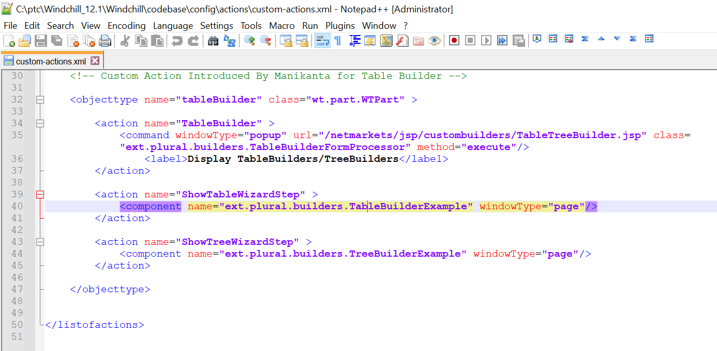

1. Stop Windchill, clean cache and start Windchill.

### Tree Builder:

1. Create a Tree builder class as shown below.

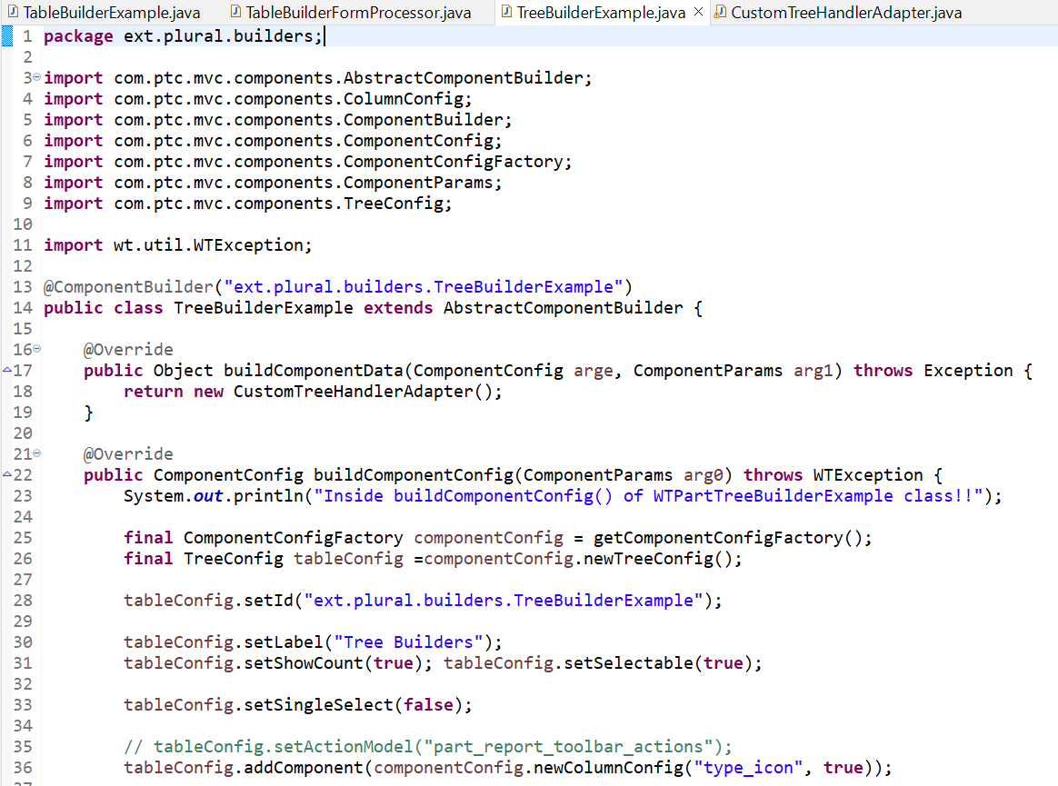

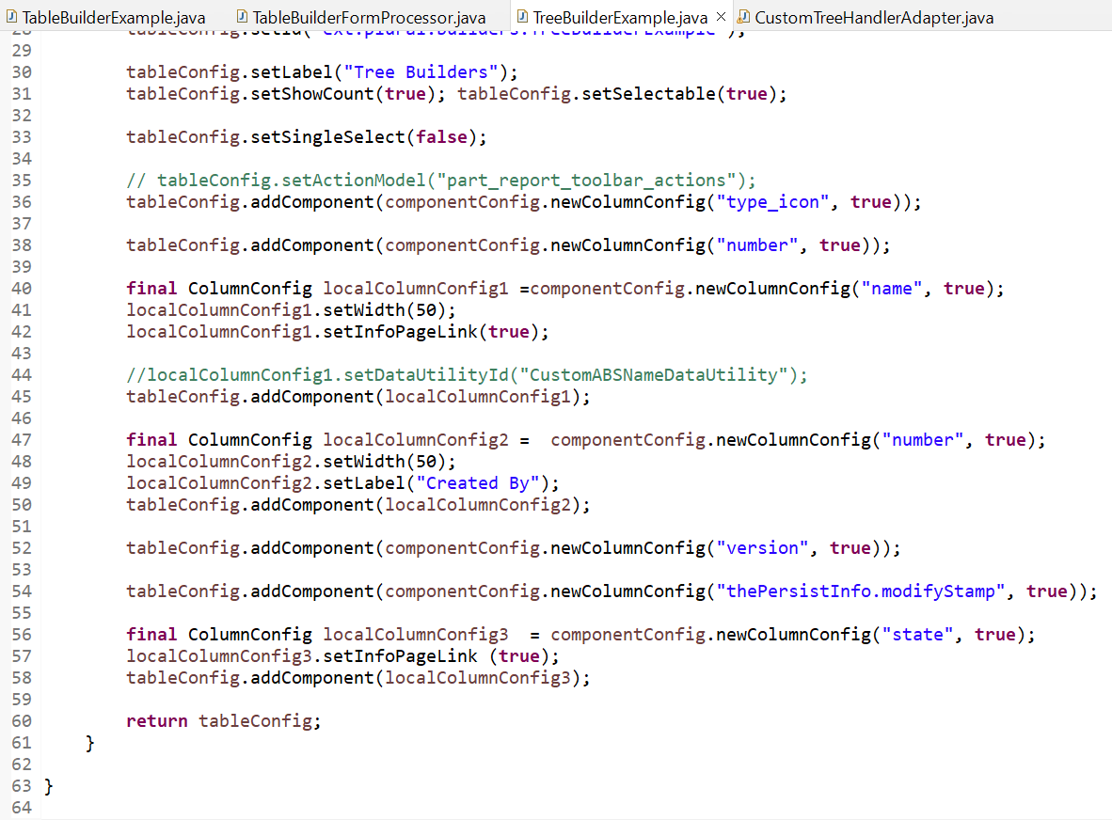

1. Create the Adapter class as shown below.

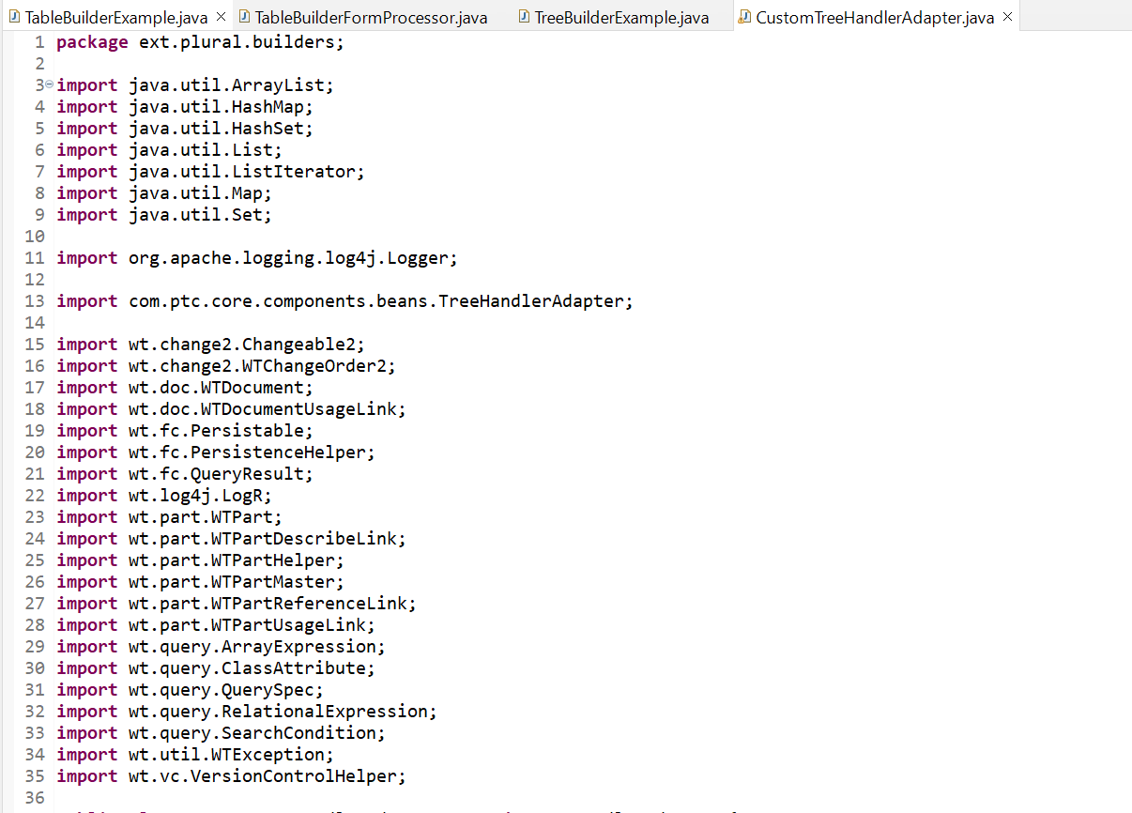

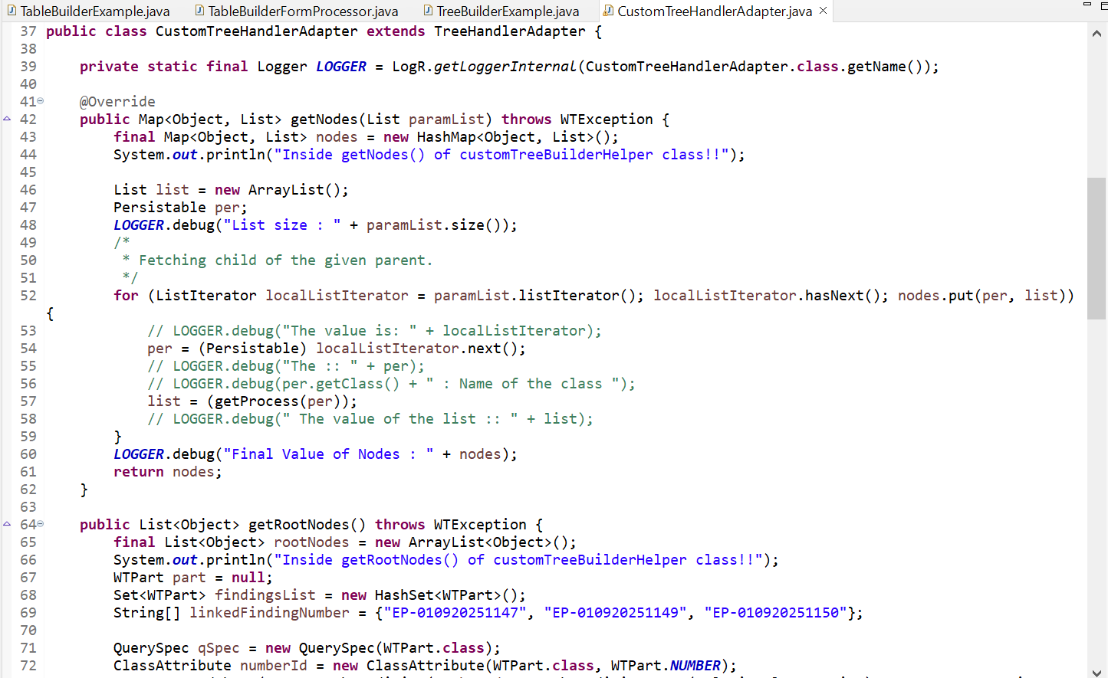

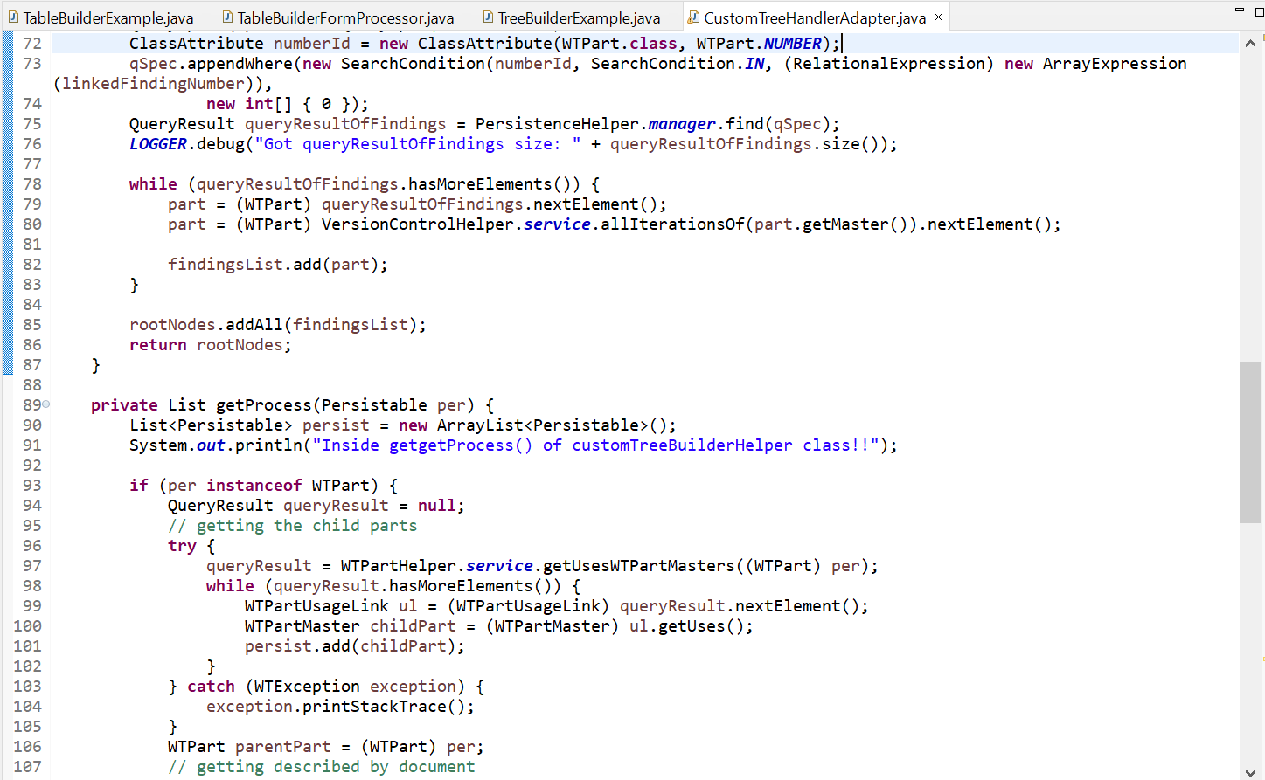

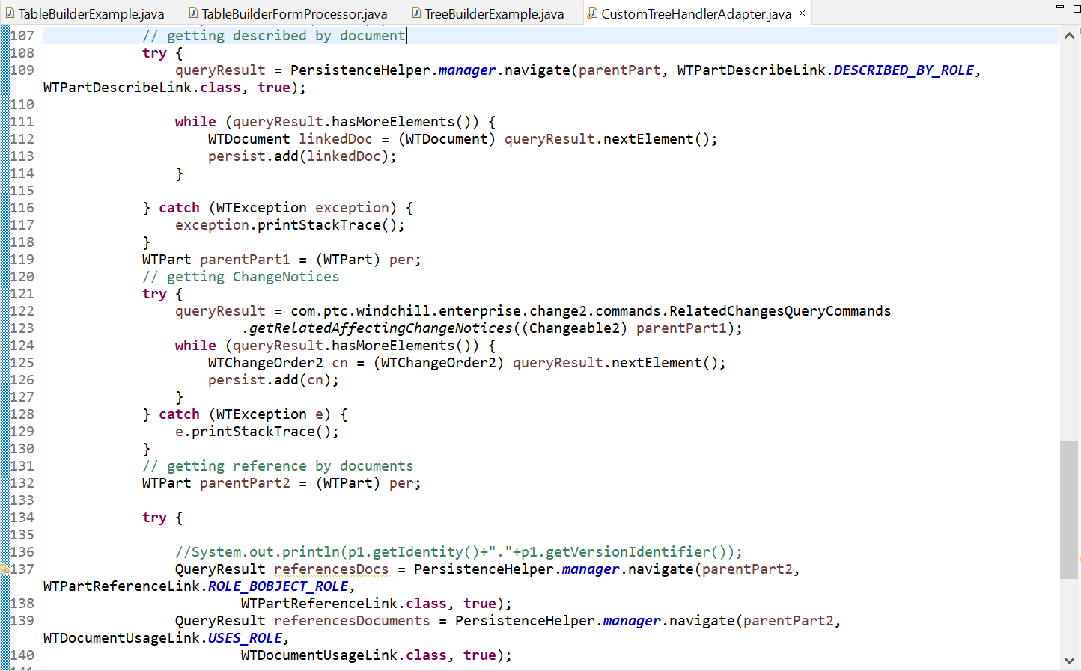

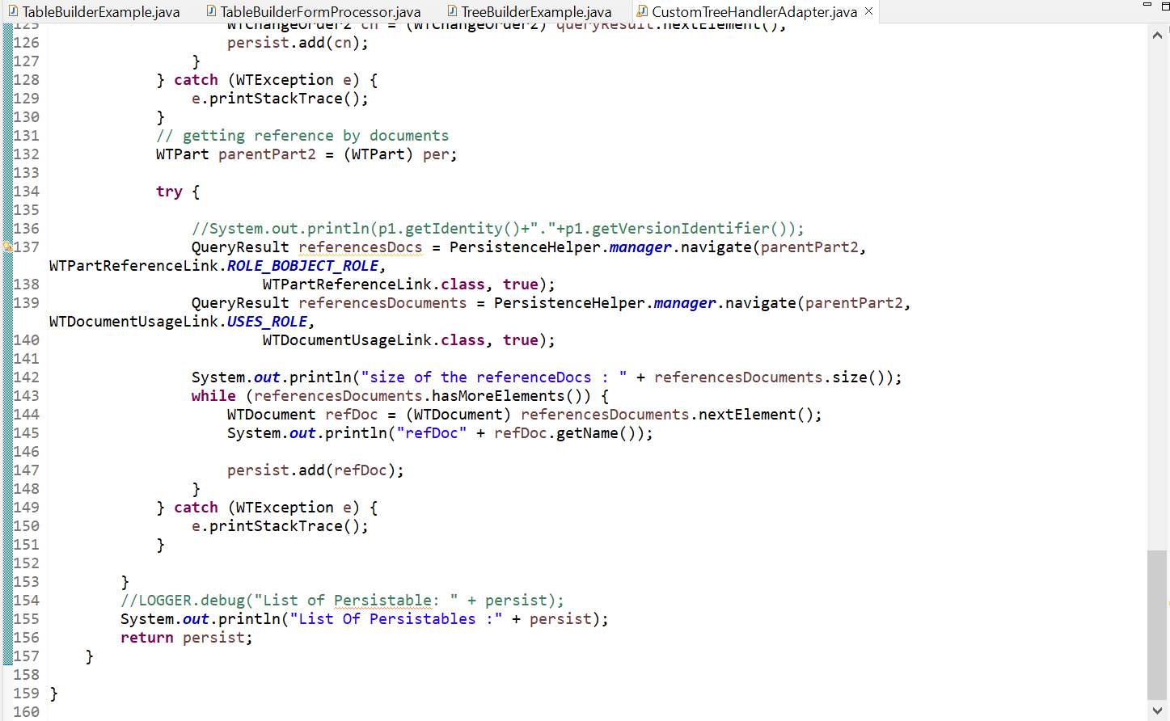

1. Register the table builder in **codebase/config/mvc/custom.xml** as shown below.

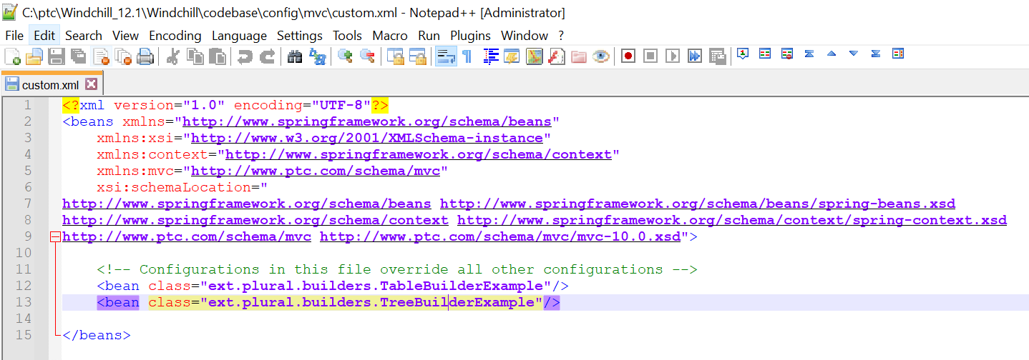

1. Create the JSP page as shown below.

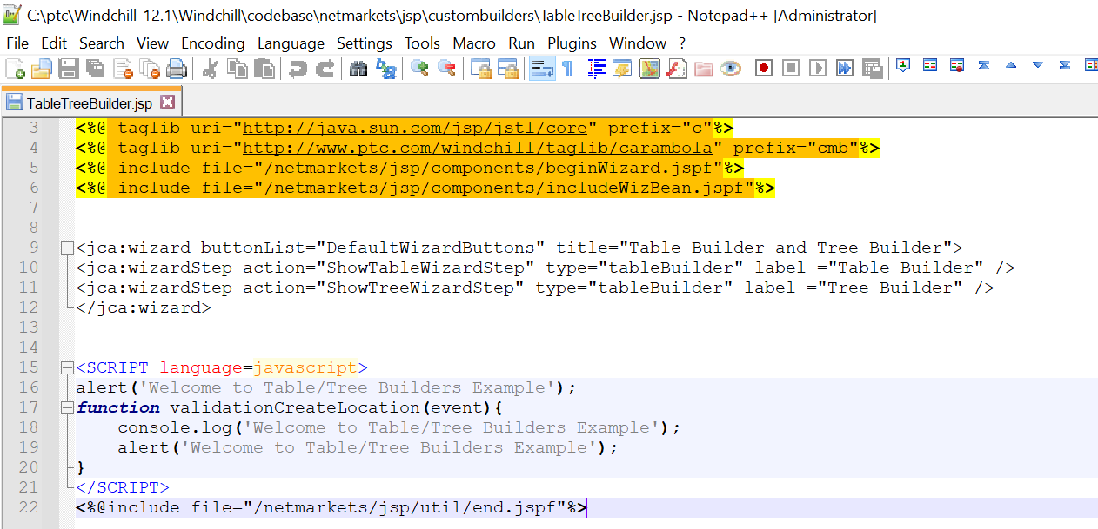

1. Create a Form Processor class as shown below to link it to the action.



1. Add the below entries as shown below.



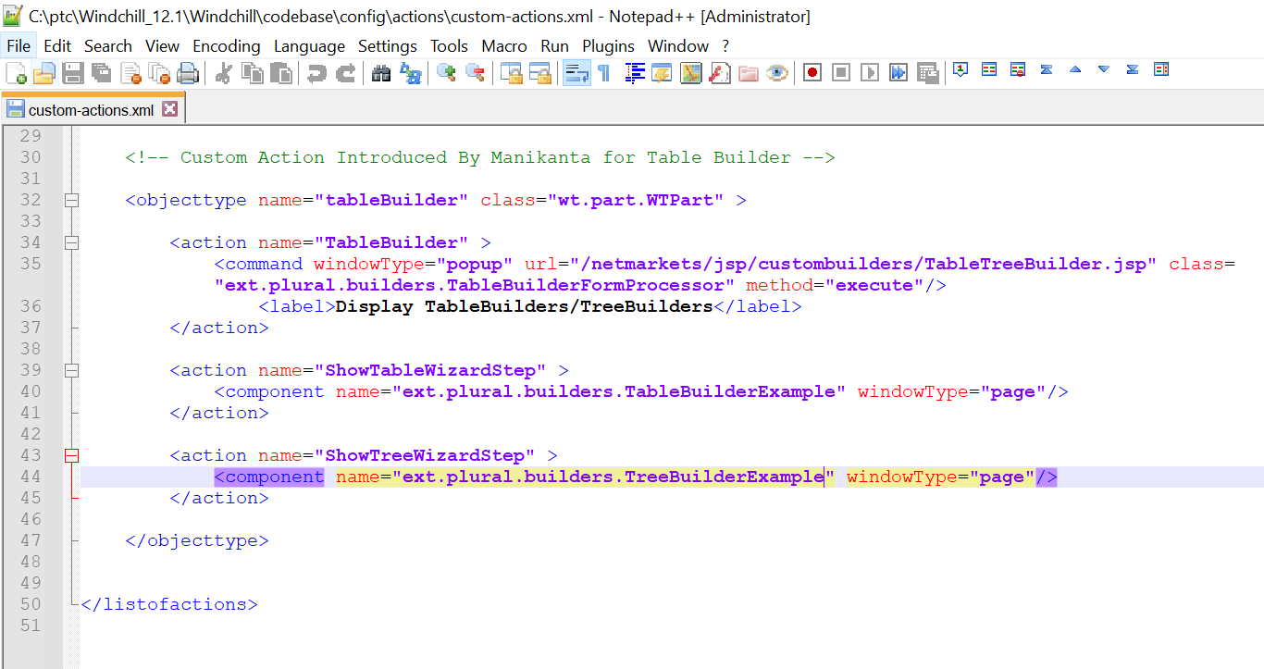

1. Stop Windchill, clean cache and start Windchill.

### Results Verification:

1. Action is visible on the WTPart successfully.

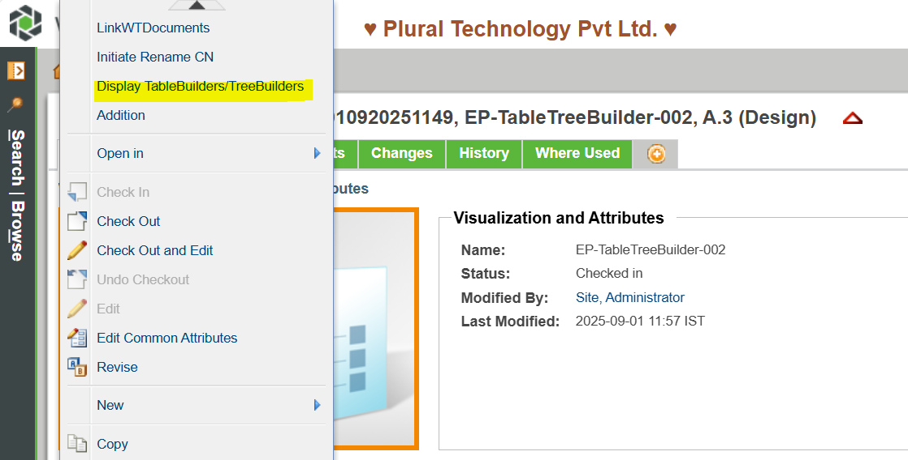

1. Alert message is triggering successfully.

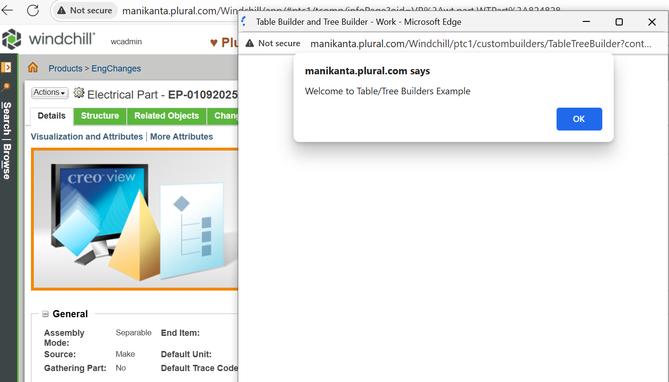

1. Table Builder section is launching successfully.

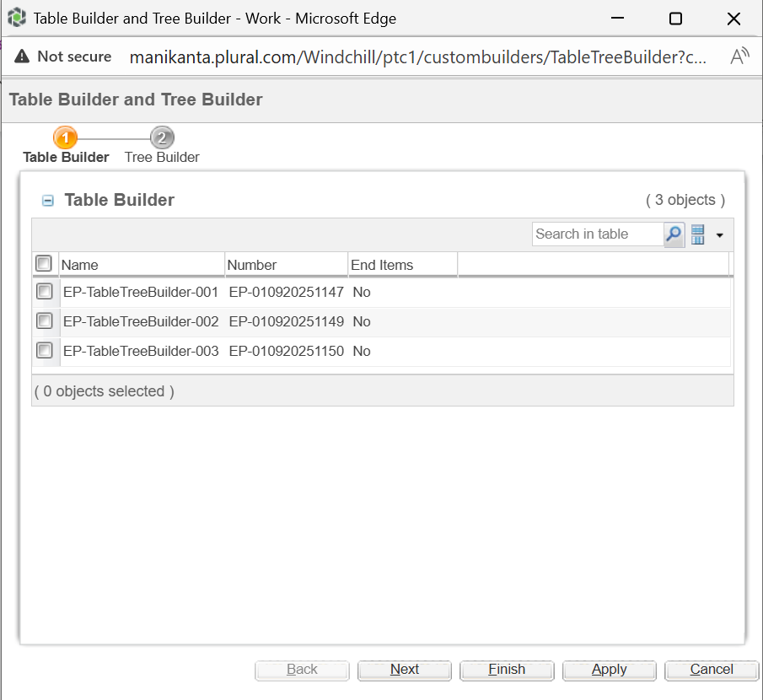

1. Tree Builder section is getting launched successfully.

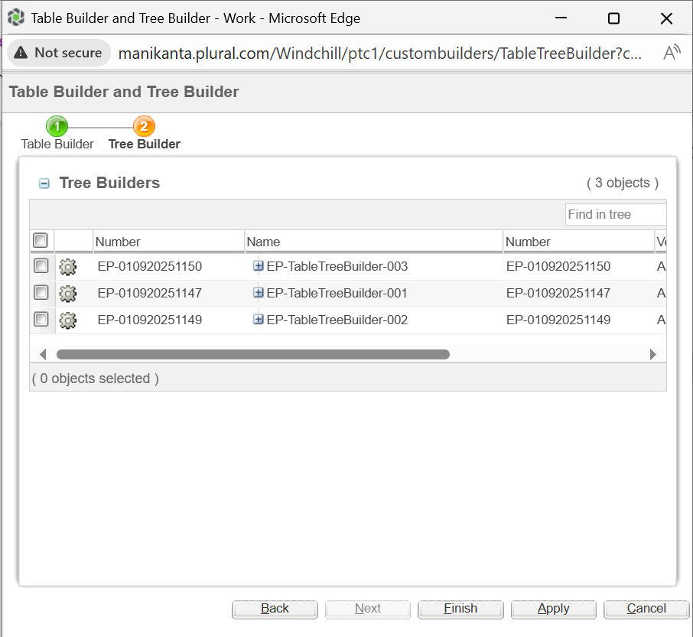

1. Expanded the tree structure successfully.

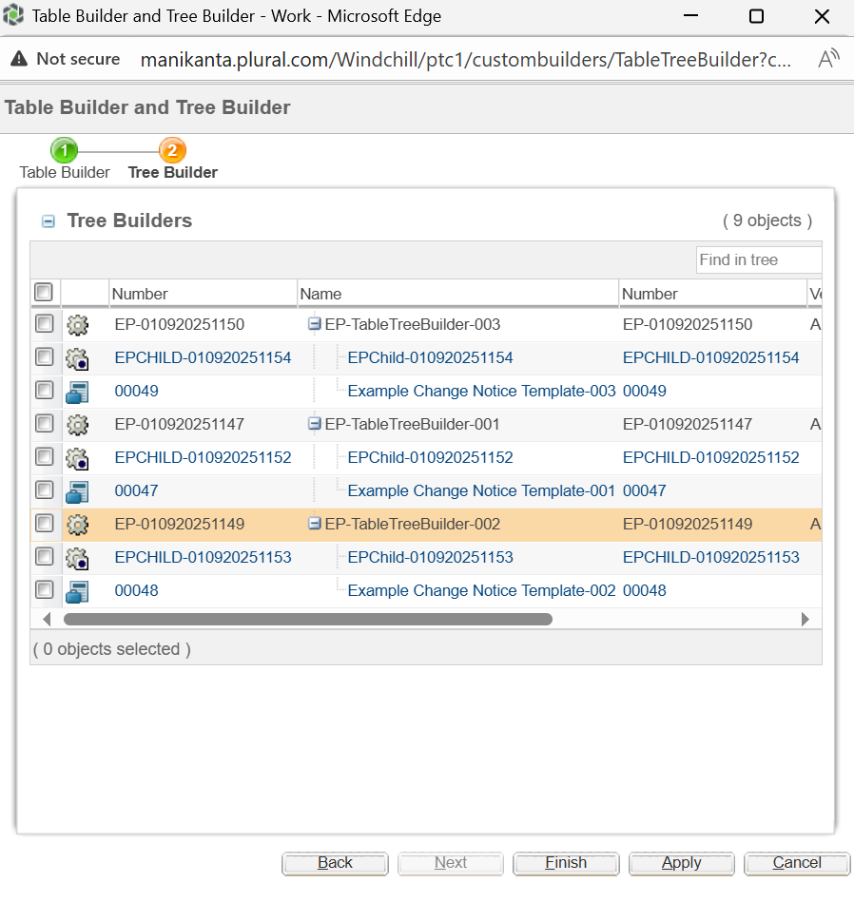

### How to add custom attributes to the Table Column

1. Create the data utility to get the IBA value as shown below.

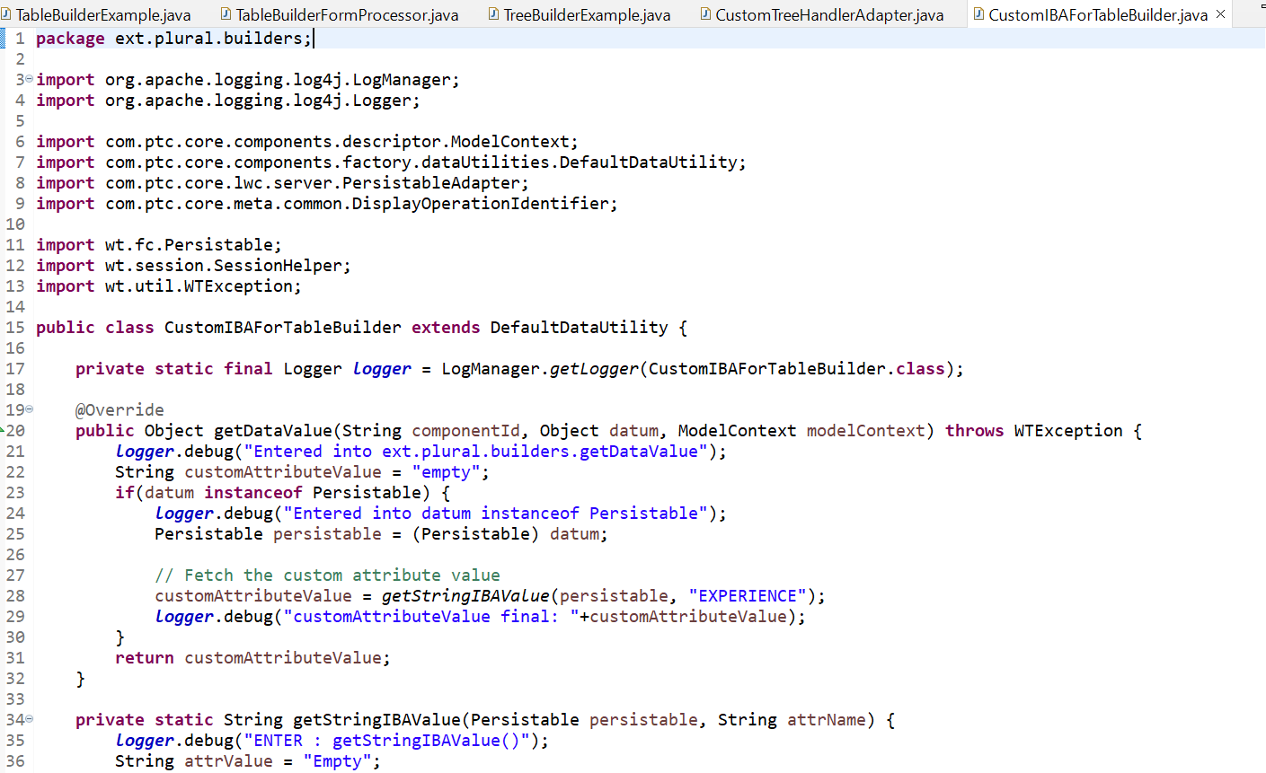

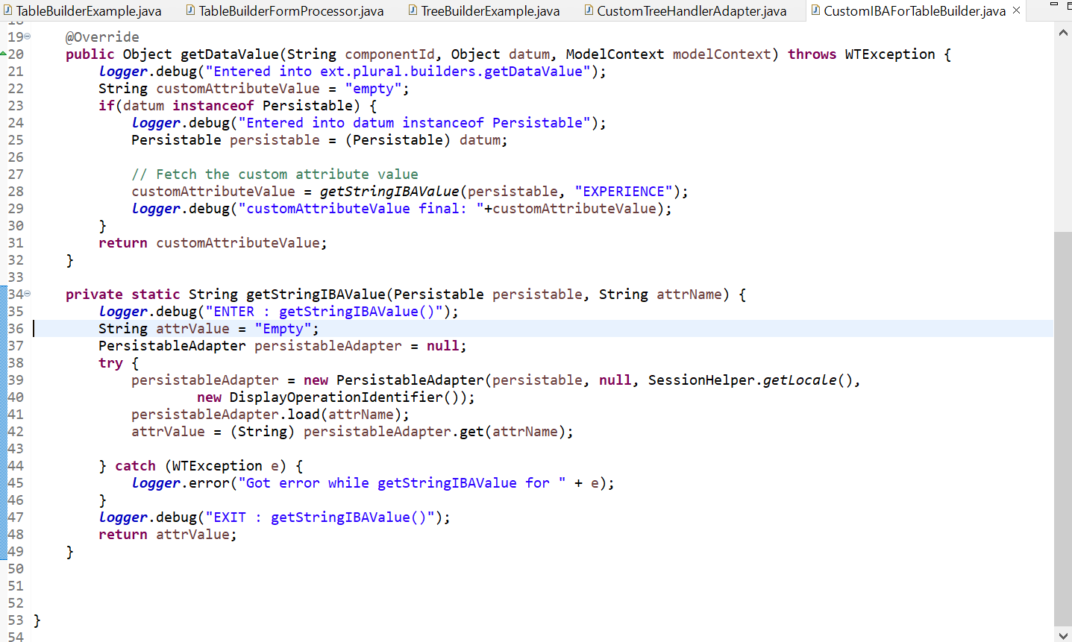

1. Register the data utility in site.xconf file as shown below.

<Service name="com.ptc.core.components.descriptor.DataUtility">

<Option serviceClass="ext.plural.builders.CustomIBAForTableBuilder" requestor="java.lang.Object" selector="CustomIBAForTableBuilder" cardinality="duplicate" targetFile="codebase/service.properties"/>

</Service>

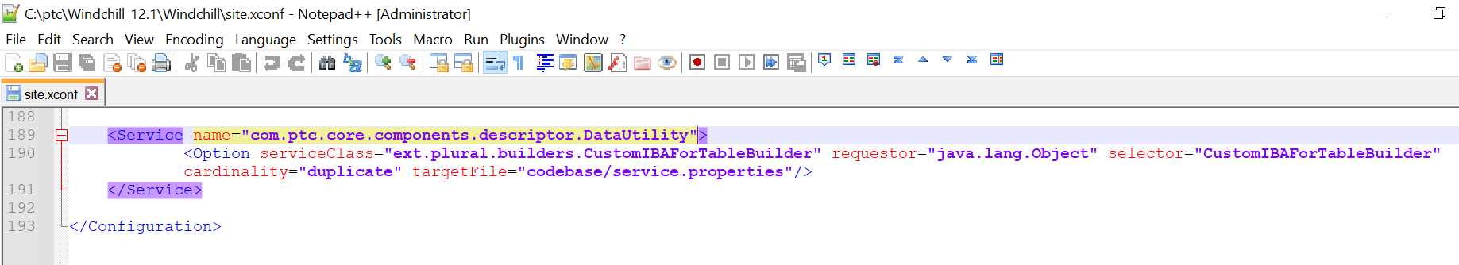

1. Update the Table Builder compoment config as shown below.

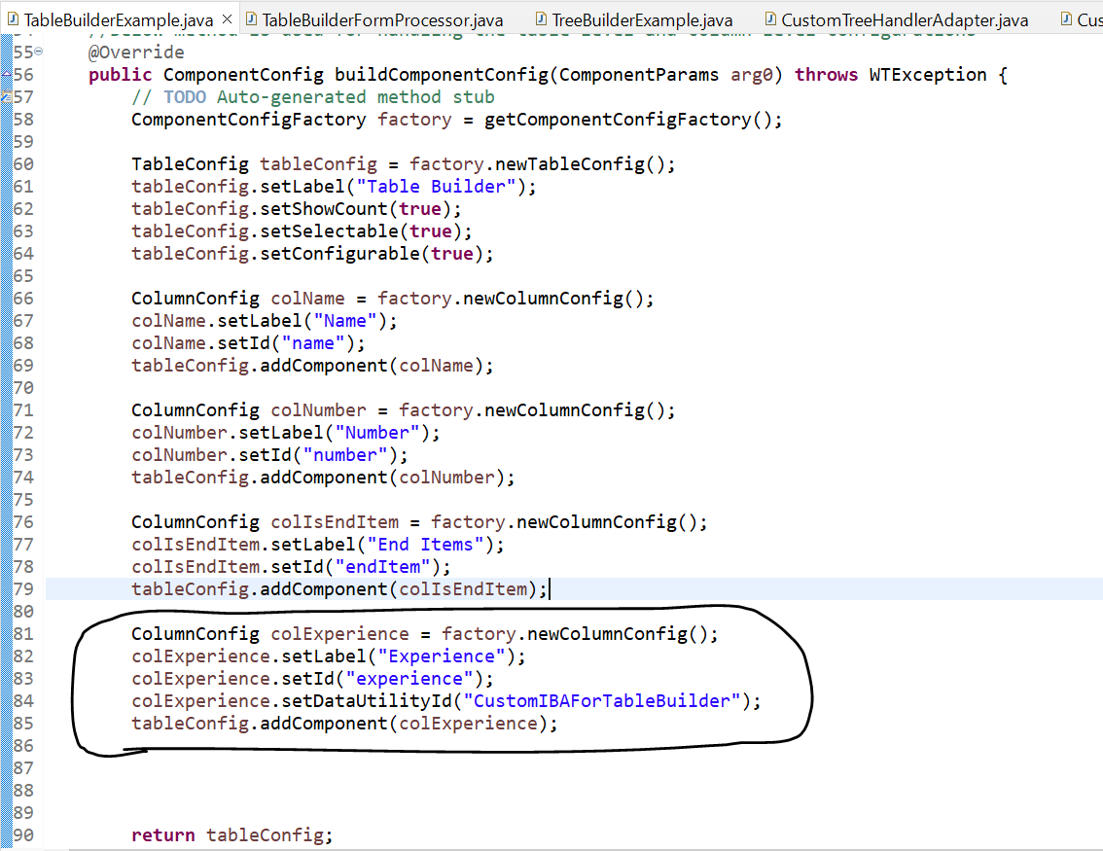

1. Execute xconfmanager -p and restart Windchill.
2. Below are the results that are achieved successfully.

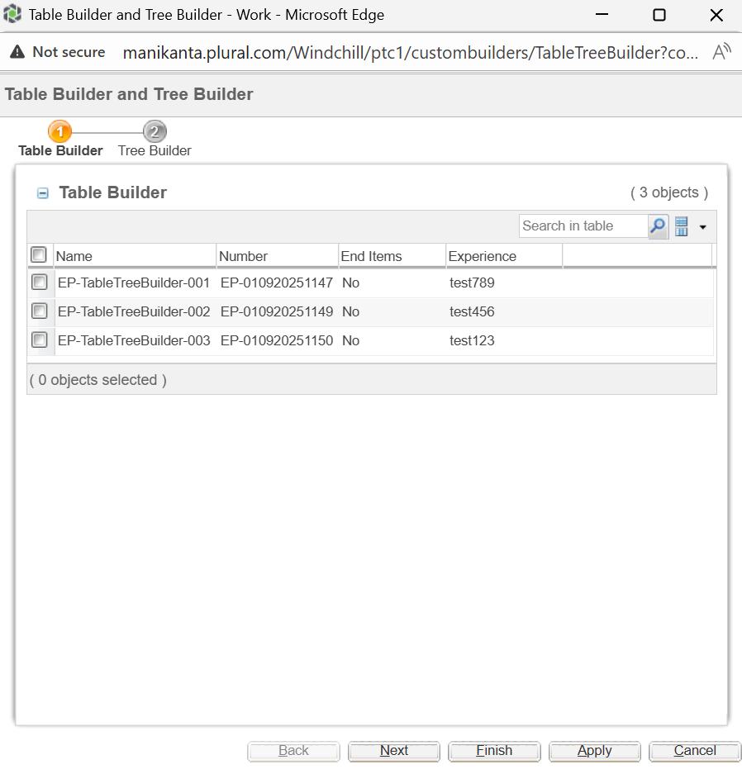

## Reference:

[Constructing and Rendering a Table Using the JSP Framework](https://support.ptc.com/help/wnc/r12.1.1.0/en/#page/Windchill_Help_Center/customization/WCCG_UICust_PresentInfoUI_ConstructRender.html#)